Media Brief

By: Sofia Romualdez, Jerome Arcangel, and Alex Guerrero

Product Identification 3
Product & Product Category 3
Product/Brand Findings 3
Loyalty Programs 3
Private Brands 3
Health Expertise 3
Digital Strategies 3
Other Findings 5
Current Users/ Target Definition 6
Demographics 6
Current Users 8
Leisure Habits/Personal Characteristics 8
Day in a Life 9
Media Habits 10
Additional Data 11
Geography 12
Geographic Priorities 12
Priority #1: Quebec 13
Priority #2: Ontario 13
Seasonality 13
Competition 14
Promotions From Competitors 15
Citations 17

Client: Loblaws
Product: Loblaws
Group Members: Sofia Romualdez
Alex Guerrero
Jerome Arcangel
Instructor: Colin Robey
____________________________________________________________________________

Product Identification

Product & Product Category
Loblaws is a Canadian grocery chain that is known for their own personal brands like Joe Fresh, President’s Choice, no name, and Life Brand.

Product/Brand Findings

Loyalty Programs
PC Plus and Shoppers Optimum were two of Canada’s most successful loyalty programs. The merging of Shoppers Drug Mart and Loblaws provides the Loblaws company to capitalize on the success of both the brand’s personal loyalty card, as well as the Shoppers Optimum card (Euromonitor, 2018).

Private Brands
Loblaws is famous for their lines of private labels, the notable ones being the no name brand and the President’s Choice brand. President’s Choice is one of Canada’s most successful private labels and offers customers a premium food option across a wide range of food types and categories. The private brand offers a large array of product lines in order to enter the different food market categories (Euromonitor, 2018).

Health Expertise
Through the merger between Shoppers Drug Mart into the Loblaws group, Loblaws has invested a significant amount of money to improve their health retail lines. The investments into optical services and wellness stations helps gear the company towards older consumers, and helps put more focus on other health related categories as well (Euromonitor, 2018).

Digital Strategies
Loblaws has been investing more into digital channels and into grocery ecommerce. It currently operates five online shopping platforms: BeautyBOUTIQUE.ca, JoeFresh.ca, mypharmacy.shoppersdrugmart.ca, wellwise.ca, and the click and collect services at the supermarkets. In early 2018, Loblaws has decided to aggressively expand its online grocery delivery capabilities, with the aim to make home grocery delivery a viable option for 70% of Canadians by the end of the year (Euromonitor, 2018).
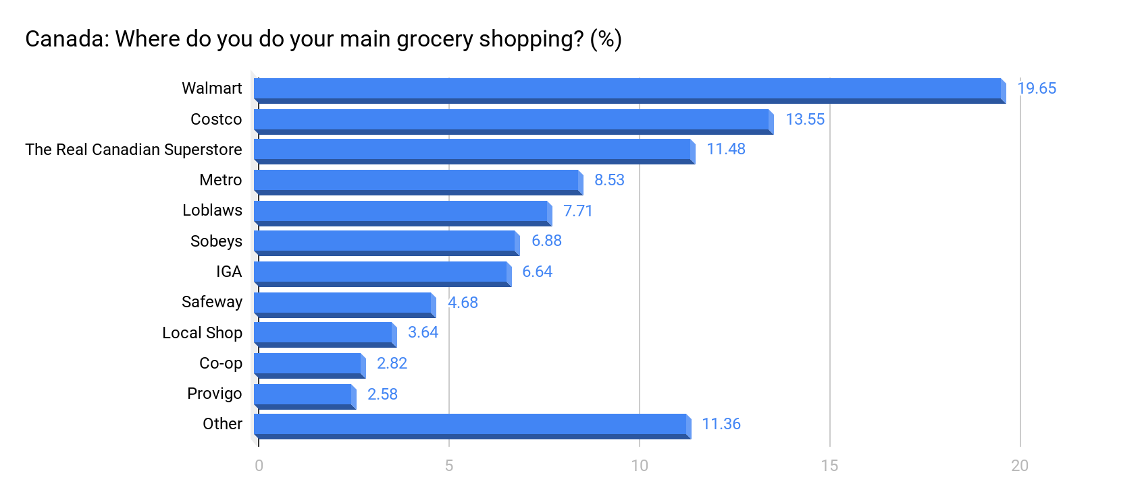

Source: Statista

- Loblaws controls 19.19% of the Canadian grocery market (This comes from the combination of Loblaws and The Real Canadian Superstore market shares).
- Is capable of competing with American owned brands like Walmart.
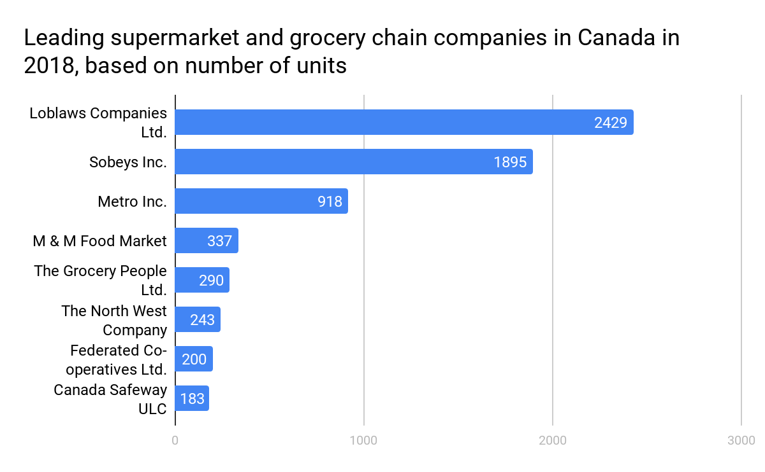
Source: Statista

- Loblaws is one of the leading Canadian owned groceries
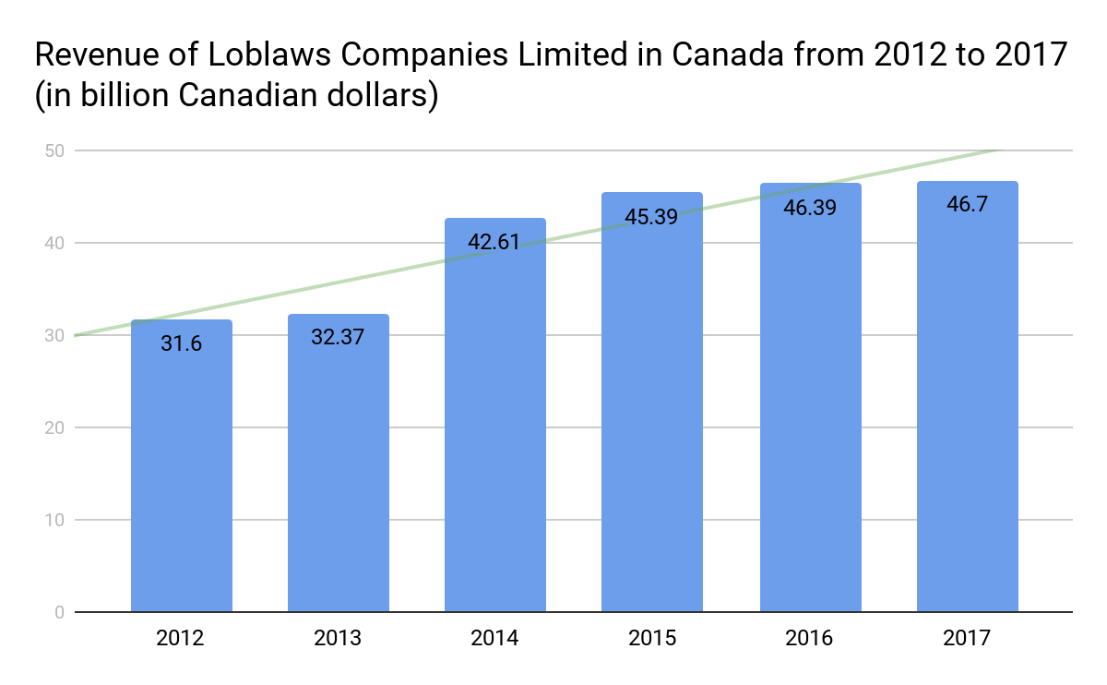
Source: Statista

- Loblaws’ revenue has been steadily increasing since 2014.

Other Findings
- Entered the Asian grocery market by purchasing T&T.
- The Canadian grocery e-commerce market is estimated to grow. It already rose by 30% in 2017 (eMarketer, 2018).
- The Loblaw Company CSR (Corporate Social Responsibility) focuses on tackling an issue like childhood hunger and putting women’s health first (Loblaw, 2018).
- Loblaws actively supports two main charities: PC Children’s Charity and the SHOPPERS LOVE. YOU.

Current Users/ Target Definition

Demographics

Age - All Food Shopping - Types of Stores HH Shop At - Any
Age | CDN POP % | Users % | Index
12-17 | 7.3 | 1.4 | 19
18-24 | 10.6 | 6.0 | 56
25-34 | 16.0 | 16.5 | 104
35-49 | 22.8 | 24.9 | 109
50-64 | 24.3 | 28.3 | 117
65+ | 19.0 | 22.9 | 121

Source: VIVIDATA 2017 Q2 Readership and Product Database. IMS. Path: All Food Shopping/Types of Stores HH Shop At/Any

- 76.1% of grocery shoppers are 35+ years old. They are at least 9% more likely to shop at grocery stores than other age groups.
- 65+ year olds are 21% more likely to purchase from grocery stores, and 22.9% of them already do.

Age - Loblaws
Age | CDN POP % | Users % | Index
12-17 | 7.3 | 3.0 | 40
18-24 | 10.6 | 4.8 | 44
25-34 | 16.0 | 17.4 | 109
35-49 | 22.8 | 28.3 | 121
50-64 | 24.3 | 27.0 | 112
65+ | 19.0 | 19.5 | 108

Source: VIVIDATA 2017 Q2 Readership and Product Database. IMS. Path: All Food Shopping/Types of Stores HH Shop At/Any

- 72.7% of Loblaws customers are 25-64 years old.
- 28.3% of Loblaws customers are 35-49 years old, and are 21% more likely to shop there than other age groups.

Gender - All Food Shopping - Types of Stores HH Shop At - Any
Gender | CDN POP % | Users % | Index
Male | 49.3 | 40.5 | 82
Female | 50.7 | 59.5 | 117

Source: VIVIDATA 2017 Q2 Readership and Product Database. IMS. Path: All Food Shopping/Types of Stores HH Shop At/Any

- Women are 17% more likely to purchase from grocery stores.
- 100% of adults purchase from grocery stores
- Women purchase from grocery stores 19% more than men.

Gender - Loblaws
Gender | CDN POP % | Users % | Index
Male | 49.3 | 38.6 | 78
Female | 50.7 | 61.4 | 121

Source: VIVIDATA 2017 Q2 Readership and Product Database. IMS. Path: All Food Shopping/Types of Stores HH Shop At/Any

- 61.4% of Loblaws consumers are women.
- Out of 100% of adult Loblaws consumers, there are 22.8% more women customers than men.

HHI - All Food Shopping - Types of Stores HH Shop At - Any
HHI | CDN POP % | Users % | Index
Under $25,000 | 12.8 | 14.4 | 113
$25,000-$34,999 | 8.2 | 9.1 | 111
$35,000-$49,999 | 13.3 | 14.0 | 105
$50,000-$74,999 | 19.2 | 18.8 | 98
$75,000-$99,999 | 14.2 | 14.0 | 99
$100,000+ | 32.4 | 29.6 | 92

Source: VIVIDATA 2017 Q2 Readership and Product Database. IMS. Path: All Food Shopping/Types of Stores HH Shop At/Any

- 70.3% of grocery shoppers have a HHI of under $25,000-$99,999.
- Adults with a HHI of under $25,000 make up 14% of all current grocery shoppers, and are 13% more likely to grocery shop than other HHI groups.

HHI - Loblaws
HHI | CDN POP % | Users % | Index
Under $25,000 | 12.8 | 12.6 | 104
$25,000-$34,999 | 8.2 | 8.0 | 104
$35,000-$49,999 | 13.3 | 12.0 | 88
$50,000-$74,999 | 19.2 | 18.6 | 89
$75,000-$99,999 | 14.2 | 16.0 | 107
$100,000+ | 32.4 | 32.8 | 107

Source: VIVIDATA 2017 Q2 Readership and Product Database. IMS. Path: All Food Shopping/Types of Stores HH Shop At/Any

- 67.4% of Loblaws consumers have a HHI of $50,000 to $100,000+.
- Adults with a HHI of $100,000+ makeup 32.8% of Loblaws consumer base, and are 7% more likely to purchase again.

Current Users
The current users of Loblaws are aged 25-64, have a HHI starting from $50,000 to $100,000+, and are female.

Leisure Habits/Personal Characteristics

Leisure Habits
Personal Characteristics
Leisure Activities (Summary) [Sewing/Knitting] (Vertical 22.5%, Index 114) | Food Statements [Agree - I have conservative taste in food] (Vertical 38.5%, Index 115)
Products/Consumer Durables Statements [Agree - I buy goods produced by own country whenever I can] (Vertical 55.7%, Index 117) | Shopping Statements [Agree - I always use a shopping list] (Vertical 51.5%, Index 113)
Leisure Activities (Summary) [Gardening] (Vertical 26.7%, Index 106) | Diet/Health Statements [Agree - I always check the nutritional content of food] (Vertical 52%, Index 106)
Diet/Health Statements [Agree - I am concerned about the health & safety of family] (Vertical 76.4%, Index 103) | Diet Health Statements [Agree - I always look for light/diet versions of food & drink] (Vertical 41.7%, Index 107)

*Lack of indexes over 110 in VIVIDATA report - approved by Colin

Day in a Life

Susan is a 45 year old woman from Milton, Ontario. She works full-time in Advertising and lives a fast-paced lifestyle. At home, Susan has a husband and two teenaged children. Being healthy is a big part of her life, and she has always checked the nutritional content of her food (Vertical 51.49%, Index 113). Since she is cautious of of the nutritional content of her food, having light/diet versions of foods and drinks (Vertical 41.74%, Index 107) is ideal.

Susan is a family woman. When looking into buying new products, especially when it comes to food and drink, she is always concerned about the health and safety of her family (Vertical 76.35%, Index 103). As a person, Susan is very organized and always uses a list when grocery shopping (Vertical 51.49%, Index 113). Due to her mostly organized nature and the kinds of food she has eaten growing up, she has a conservative taste in food (Vertical 38.49%, Index 115).

During her spare time, Susan like to sew, knit (Vertical 22.5%, Index 114), and garden (Vertical 26.69%, Index 106). On the weekends in the summertime, she likes to go to Main St. for the farmer’s market. She enjoys local produce, baked goods, and art. As a recent advocate for ethical brands, Susan enjoys to buy goods made in Canada whenever she can (Vertical 55.73%, Index 117).

Media Habits
Media Habits
A35-65+, HHI Under $25,000 - $99,000, Male & Female
 | TV |  | Radio |  | News. |  | Magazine |  | Online
 | % | Index | % | Index | % | Index | % | Index | % | Index
Heavy | 26.22 | 133 | 20.24 | 114 | 23.52 | 119 | 23.08 | 117 | 12.77 | 76
Med/Heavy | 16.69 | 107 | 16.17 | 97 | 19.85 | 95 | 21.1 | 105 | 11.36 | 87
Medium | 23.47 | 108 | 26.77 | 100 | 18.55 | 96 | 20.28 | 101 | 26.29 | 98
Med/Light | 18.23 | 90 | 20.14 | 100 | 0.34 | 82 | 18.08 | 90 | 31.49 | 113
Light | 15.4 | 68 | 16.68 | 90 | 37.74 | 95 | 17.46 | 87 | 17.71 | 117

Source: VIVIDATA 2017. Clear Decisions.

- TV has a total percentage of 42.91% of med/heavy to heavy users.
  - The target seems to frequent television as majority are heavy users.

- Radio has a total percentage of 36.41% of med/heavy to heavy users.
  - The target also frequents Radio as majority of users are heavy and medium users.

- Newspaper has a total percentage of 43.37%
  - Newspaper is dominated by heavy users, it is worth noting that newspaper also has a significant amount of light users with a vertical percent of 37.74% and an index of 95

- Magazine has a total percentage of 44.18% of med/heavy to heavy users.

- Online has a total percentage of 49.02% of light and med/light uses
  - Online has the most lightest users out of all the media vehicles.

- Based on the media habits chart and the highlighted key information the recommended media would be TV, radio, newspaper, and magazine.

Additional Data
- Based on the clear decisions report the percentage of people who watched tv yesterday is 89.32% and the index is 107.

- Based on the clear decisions report the percentage of people who listened to the radio within the past week is 87.71% and the index is at 102.

- Based on the clear decisions report a significant amount of the target has never used public transit with a vertical percent of 27.37% and an index of 130

- A significant amount of the target has travelled in town within the past 7 days in a car/truck at around 75-99km. The vertical percentage is 9.32% and the index is 110. This signifies that there are a heavy amount of users that have travelled in-town

Geography

Grocery Shopping at Any Store
Region | CDN POP% | Category Users % | Brand Users | CDI | BDI | BOI
Atlantic | 6.71 | 7.16 | 7.6 | 107 | 113 | 95
Quebec | 23.20 | 24.57 | 19.2 | 106 | 83 | 128
Ontario | 38.68 | 37.37 | 61.4 | 96 | 159 | 60
Prairies | 18.11 | 17.94 | 5.4 | 99 | 30 | 330
BC | 13.31 | 12.96 | 6.4 | 97 | 48 | 202

Source: VIVIDATA 2017. Clear Decisions.

- The BDI for Ontario is 159. This means that a lot of Ontario based Canadian buy groceries from Loblaws.
- Although Ontario is higher in population and in brand development, Canadians in the Atlantic region are 11 percentage points more likely to buy groceries than in Ontario.
- The brand opportunity index in the Prairies is 330 (which is quite high), but has relatively low CDI and BDI. The CDI being at 99, while the BDI is at 30.
- There is high brand opportunity in the BC region due to the high BOI at 202.
- People in the BC region are more likely to shop at groceries, but less likely to shop at Loblaws.
- In the Atlantic region, there is a CDI of 107 and a BDI of 113. Having both high BDI and CDI means that Loblaws has to act both aggressively and defensively in the Canadian Atlantic market.
- Quebec is a great region for Loblaws to target due to the relatively even BDI,CDI, and BOI. The region has a CDI of 106, a BDI of 83, and a BOI a high as 128.

Geographic Priorities

Number of Loblaws Stores Based On Region
Region | Locations
Atlantic | 0
Quebec | 46
Ontario | 34
Prairies | 0
BC | 3

Source: Loblaws Store Locator 2018.

Priority #1: Quebec
Quebec is the most ideal region to target due to its high number of stores (45 to be exact) as well as high BOI. There is a good amount of stores in the region to make Loblaws more accessible to consumers. The high BOI (at 128) means that there is good opportunity in the region. Quebec also has a high CDI (at 106) which means that a large amount of French Canadians shop for groceries, but not necessarily at a Loblaws location. There is a large opportunity for Loblaws to adopt a more aggressive strategy that will help raise the BDI and market share for that region.

Priority #2: Ontario
Ontario makes an ideal secondary target because the region already has a high BDI (at 159), which means that most Ontarians are already loyal to the Loblaws brand. Though Quebec has a bit more store accessibility (due to their larger amount of locations), Ontario also has a relatively large amount of locations (at 34) that give the region slightly less accessibility to consumers. Loblaws can adopt a more defensive strategy when tackling the Ontario market because most Ontarians already buy from Loblaws regularly (Ontario makes up 61.4% of Loblaws’ brand users).

Seasonality

Food Shopping Sales Pattern
Month | J | F | M | A | M | J | J | A | S | O | N | D
Sales % | 8.2 | 8.1 | 8.0 | 8.0 | 8.5 | 8.5 | 8.6 | 8.5 | 8.4 | 8.4 | 8.3 | 8.5

Source: Monthly retail sales of grocery stores in Canada from 2015 to 2018 (in billion Canadian Dollars)*. Statista.
*Table information is loosely based on source

Sales in the year 2017 remained stable. Amounts sold at grocery stores rose up 8.6% in July due to summer harvest. Sales also rose up to 8.5% in December, despite having less selection in season due to the holiday season.

Top seasonal priorities consist of May-August and December, due to higher amounts of food and drink being bought for events being held.

Competition
Competitor #1: Sobeys
Competitor #2: Metro

Brand | Current Users
Loblaws | 25-64, HHI $50,000 to $100,000+, female.
Sobeys | 35-65+, HHI under $25,000 to $99,999
Metro | 35-65+, HHI under $25,000 to $75,000

Source: Resource Reference Brand Specific Data.
- Loblaws has a different age group than competitors with users aged 25-64 compared to the competitors older aged users 35-65+
- Loblaws users have a higher HHI than competitors at $50,000 to $100,000+.

Competitive Geographic Analysis
Region | CDN POP % | CDI | Loblaws BDI | Sobeys BDI | Metro BDI
Atlantic | 6.71 | 107 | 114 | 701 | 0
Quebec | 23.2 | 106 | 83 | 12 | 250
Ontario | 38.68 | 96 | 159 | 57 | 107
Prairies | 18.11 | 99 | 30 | 147 | 2
BC | 13.31 | 97 | 48 | 12 | 1

Source: Resource Reference Brand Specific Data.

- Sobeys has an extremely High BDI at 701 but a low CDI of 107 in comparison to the BDI in the Atlantic region, based off the analysis Sobeys is significant in the Atlantic region
- Loblaws has a high BDI of 114 and a high CDI of 107 in the Atlantic regions
- Metro has a high BDI of 250 and a low CDI of 106 in Quebec, Metro seems to be significant in Quebec
- Loblaws has a high BDI of 159 and a low CDI of 96 in Ontario, based on the analysis Loblaws is significant in Ontario
- Sobeys has a high BDI of 147 but the CDI is at a low of 99 in the Prairies.
- Metro is based heavily based in Quebec and Ontario
- Sobeys is primarily based in the Atlantic and Prairie regions.

Promotions From Competitors

- Sobeys is sponsoring the “Canaccord Genuity Great Camp Adventure walk” in support of the SickKids Foundation for 5 years. The “Adventure Walk” is a fundraising event where participants walk up to 20 kilometres. Sobeys will be supplying the “Adventure Walk” with snacks and refreshments throughout the event. (“Sobeys Inc. announces five-year sponsorship”, 2017).
- Sobeys has a strong community presence as they donate millions to many community organizations, Sobeys has a program called the “Better Food Fund” and this program “supports the advancements of better food through donations and partnerships” (“Social Responsibility”, 2014)
- Sobeys has partnered up and became an official sponsor for MLSE teams. Sobeys will be making their food available inside the Scotiabank Arena and at the games. (“Sobeys becomes official sponsor for MLSE teams”, 2018)
- Sobeys has made a generous donation of $250,000 to the Special Olympics summer games as a celebration of the 100 day countdown to the summer games. (“Sobeys Announces $250,000 for Special Olympics National Summer Games”, 2018)
- Metro Ontario has created an aggressive summer campaign in 2014 with an integrated program that consists of partnerships,print advertising, in-store events, and online initiatives. They were the exclusive grocery sponsor of the food festival “Taste of Toronto”. Metro had many interactive experiences in the event such as the “Metro Master Class” where people were able to learn to prepare their own dishes. And the “Metro Market & Lounge” which allowed a place for guests to relax and purchase ingredients from a virtual pop-up shop. (“Metro Ontario Launches Taste Summer Campaign”, 2014)
- Metro Ontario is a returning sponsor of a culinary event called “Taste of Toronto” the event allows people to prepare and taste many dishes alongside local celebrity chefs all while using Metro’s supplied ingredients. Metro will be hosting 20 sessions throughout the event. (“Metro Ontario returns as sponsor of Toronto culinary event”, 2017)

Grocery Stores – Share of Voice (%)
Brand | Total | News. | Magazine | OOH | Radio | TV | Online
Loblaws | 10.12 | 11.91 | 41.51 | 0.21 | N/A | N/A | 16.77
Sobeys | 8.46 | 14.85 | 6.62 | N/A | 9.74 | N/A | 8.85
Metro | 12.23 | 16.39 | N/A | 8.23 | 3.2 | 22.03 | 18.21

Source: Competitor Media Spending (Grocery).

- Based on the Share of Voice, Loblaws is spending the most money in Magazine with a share of 41.51% compared to the competitors.
- Metro is spending the most and is the only competitor with shares of 22.03%

Grocery Stores – Spend by Medium (%)
Brand | News. | Magazine | OOH | Radio | TV | Online
Loblaws | 32.67 | 39.15 | 0.19 | N/A | N/A | 28
Sobeys | 48.72 | 7.48 | N/A | 42.43 | N/A | 17.69
Metro | 37.19 | N/A | 5.96 | 5.94 | 25.75 | 25.16
Total | 27.74 | 9.54 | 8.86 | 22.68 | 14.29 | 16.89

Source: Competitor Media Spending (Grocery).

- Based off of the Chart Loblaws has a larger medium in newspapers and magazines, newspaper has a percentage of 32.67% and magazines has a percentage of 39.15%
- A common medium seems to be newspapers as all brands are spending a significant amount into it.
- Sobeys has the highest percentage in Radio at 42.43%.
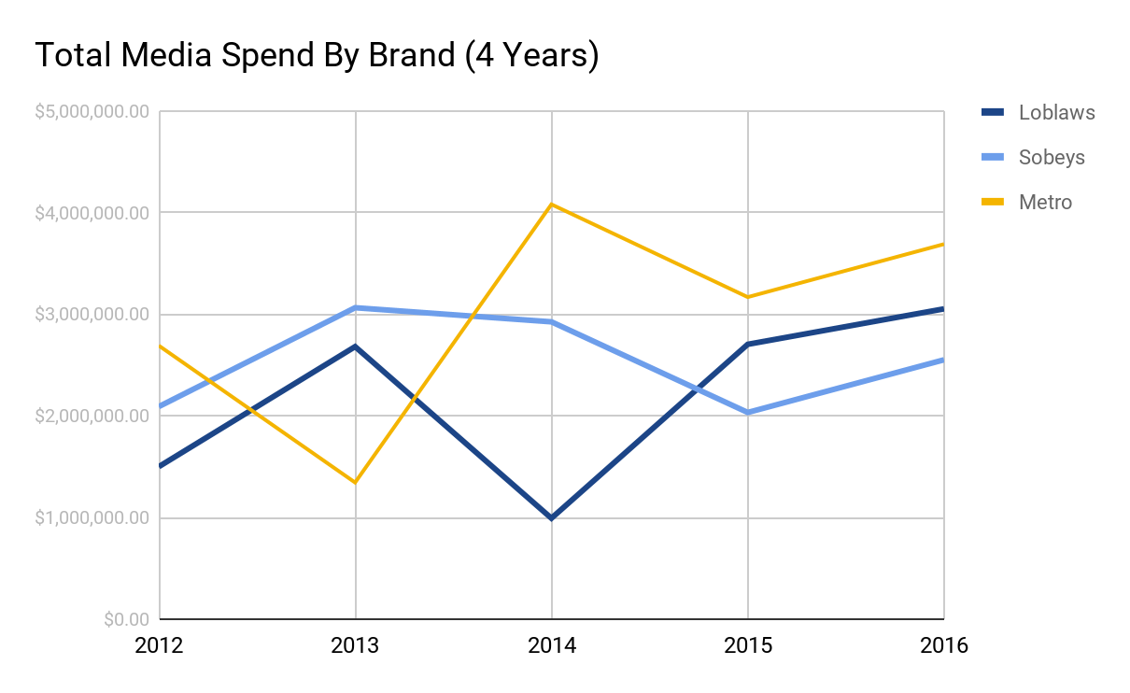
Source: Competitor Media Spending (Grocery).

- Metro peaked in total media spending in 2014, they still maintain the highest in total media spending.
- Loblaws was at a low in 2014 but raised substantially in 2015 and is in the middle for the total media spend in 2016.
- Sobeys has the least amount of money spent on media out of the other 2 brands in 2016.
- In conclusion Metro is spending the most in media in 2016 and Loblaws is in second.

Citations
Briggs, P., Creamer, S., & Kim, A. (2018, January). Ecommerce in Canada 2018: EMarketer's Latest Forecast, with a Focus on Grocery. Retrieved November 19, 2018, from http://totalaccess.emarketer.com/reports/viewer.aspx?r=2002204&ipauth=y

CSG. (2018, March). Leading supermarket and grocery chain companies in Canada in 2018, based on number of units. Retrieved November 19, 2018, from https://www-statista-com.library.sheridanc.on.ca/statistics/881815/supermarket-and-grocery-chain-units-canada/

Loblaw Companies Limited. (n.d.). Charitable Giving. Retrieved December 11, 2018, from https://www.loblaw.ca/en/responsibility/community/charitable-giving.html

Cint. (2018, August). Canada: Where do you do your main grocery shopping? Retrieved November 19, 2018, from https://www-statista-com.library.sheridanc.on.ca/statistics/934973/canada-main-grocery-shopping-locations/

Statista. (2018). Supermarkets and Grocery Stores in Canada. Retrieved November 19, 2018, from https://www-statista-com.library.sheridanc.on.ca/study/34640/supermarkets-and-grocery-stores-in-canada-statista-dossier/

Industry Canada, & StatCan. (2017, October). Number of grocery stores in Canada as of December 2016, by region. Retrieved November 19, 2018, from https://www-statista-com.library.sheridanc.on.ca/statistics/459530/number-of-grocery-stores-by-region-canada/

Grocery_Crosstab [PDF]. (2018, November 21). Vividata 2017 Q2 Readership and Product Database.

Robey, C. (2018). Resource_Reference_Brand Specific Data [XLSX].

Monthly retail sales of grocery stores in Canada from 2015 to 2018 (in billion Canadian dollars)* [Chart]. (2018). In Statista. Retrieved November 22, 2018, from https://www-statista-com.library.sheridanc.on.ca/statistics/461774/monthly-retail-sales-of-grocery-stores-canada/

Loblaws_Media_Brief_Crosstab [PDF]. (2018, November 16). Vividata 2017 Q2 Readership and Product Database.

Loblaws_Leisure_Habits_Crosstab [PDF]. (2018, November 16). Vividata 2017 Q2 Readership and Product Database.

Euromonitor. (2018, June 21). Loblaws Cos Ltd: Global Company Profile. Retrieved November 19, 2018, from http://www.portal.euromonitor.com.library.sheridanc.on.ca/portal/analysis/tab#

Mobile Investment Conference. (2017, September 8). Retrieved December 11, 2018 from https://ceo.ca/@nasdaq/sobeys-inc-announces-five-year-sponsorship-with-the

Sobeys. (n.d.). Social Responsibility. Retrieved December 11, 2018 from https://corporate.sobeys.com/social-responsibility/

Venkatesan, D. (2018, November 9). Sobeys becomes official sponsor for MLSE teams. Retrieved December 11, 2018 from http://mediaincanada.com/2018/11/09/sobeys-becomes-official-sponsor-for-all-six-mlse-teams/

Sobeys Announces $250,000 for Special Olympics National Summer Games. (2018, June 19). Retrieved December 11, 2018 from https://so2018.specialolympicsns.ca/sobeys-announces-25000-in-support-to-special-olympics-national-summer-games/

Metro Ontario returns as sponsor of Toronto culinary event. (2017, June 14). Retrieved December 11, 2018, from http://www.canadiangrocer.com/categories/metro-ontario-returns-as-sponsor-of-toronto-culinary-event-73543

Metro Ontario Launches Taste Summer Campaign - Includes sponsorship of inaugural Taste of Toronto Festival. (2014, July 24). Retrieved December 11, 2018, from https://www.newswire.ca/news-releases/metro-ontario-launches-taste-summer-campaign---includes-sponsorship-of-inaugural-taste-of-toronto-festival-515154091.html

