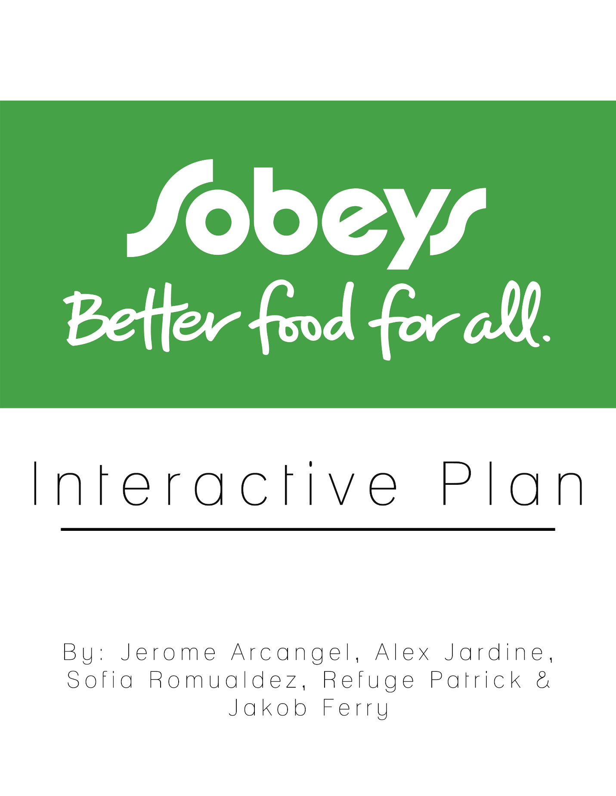

Executive Summary
The aim of this report is to develop an interactive marketing plan for the Sobey’s Merchandising Innovation and Development department and the Sobey’s marketing team. The agency’s objective is to attract shoppers to shop online at Sobey’s through their website. The agency examined a variety of digital touchpoints, tactics and executions to improve the online shopping experience. The agency’s main focus is to attract more millennials between the ages of 18 – 34 through the month of October 2018. The agency is confident in achieving these objectives by introducing unique takes on ethnic cuisines to the Sobey’s website and mobile app.
Retail Image
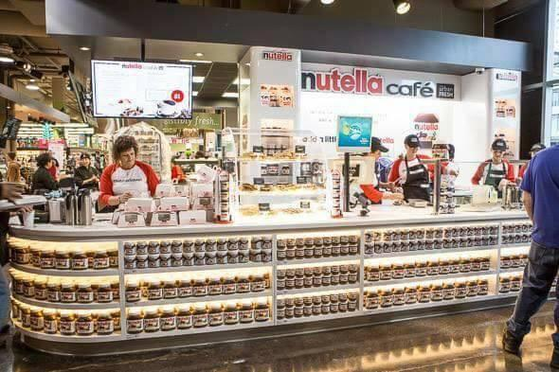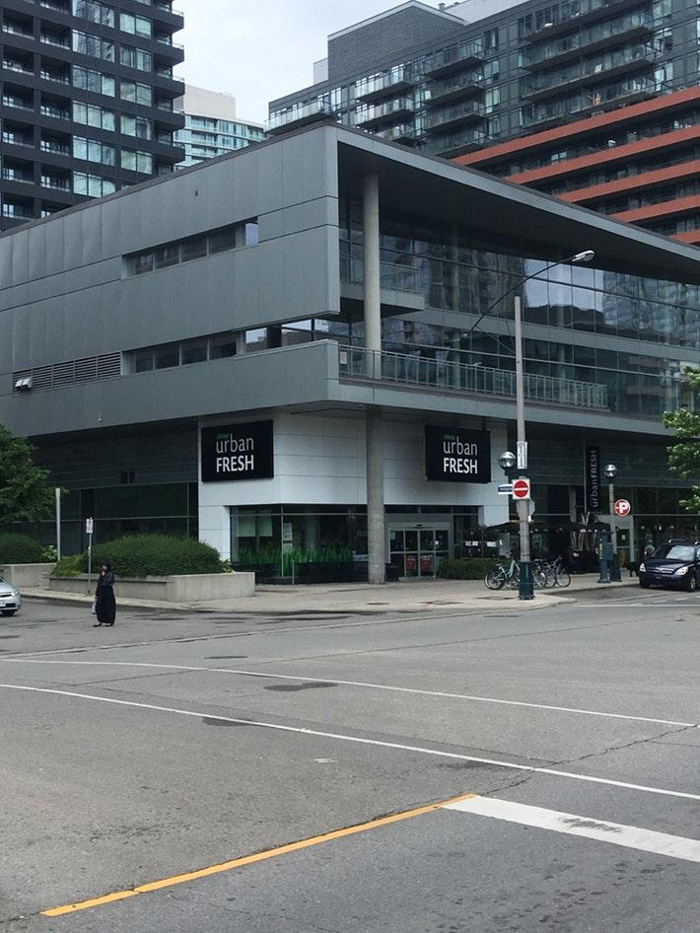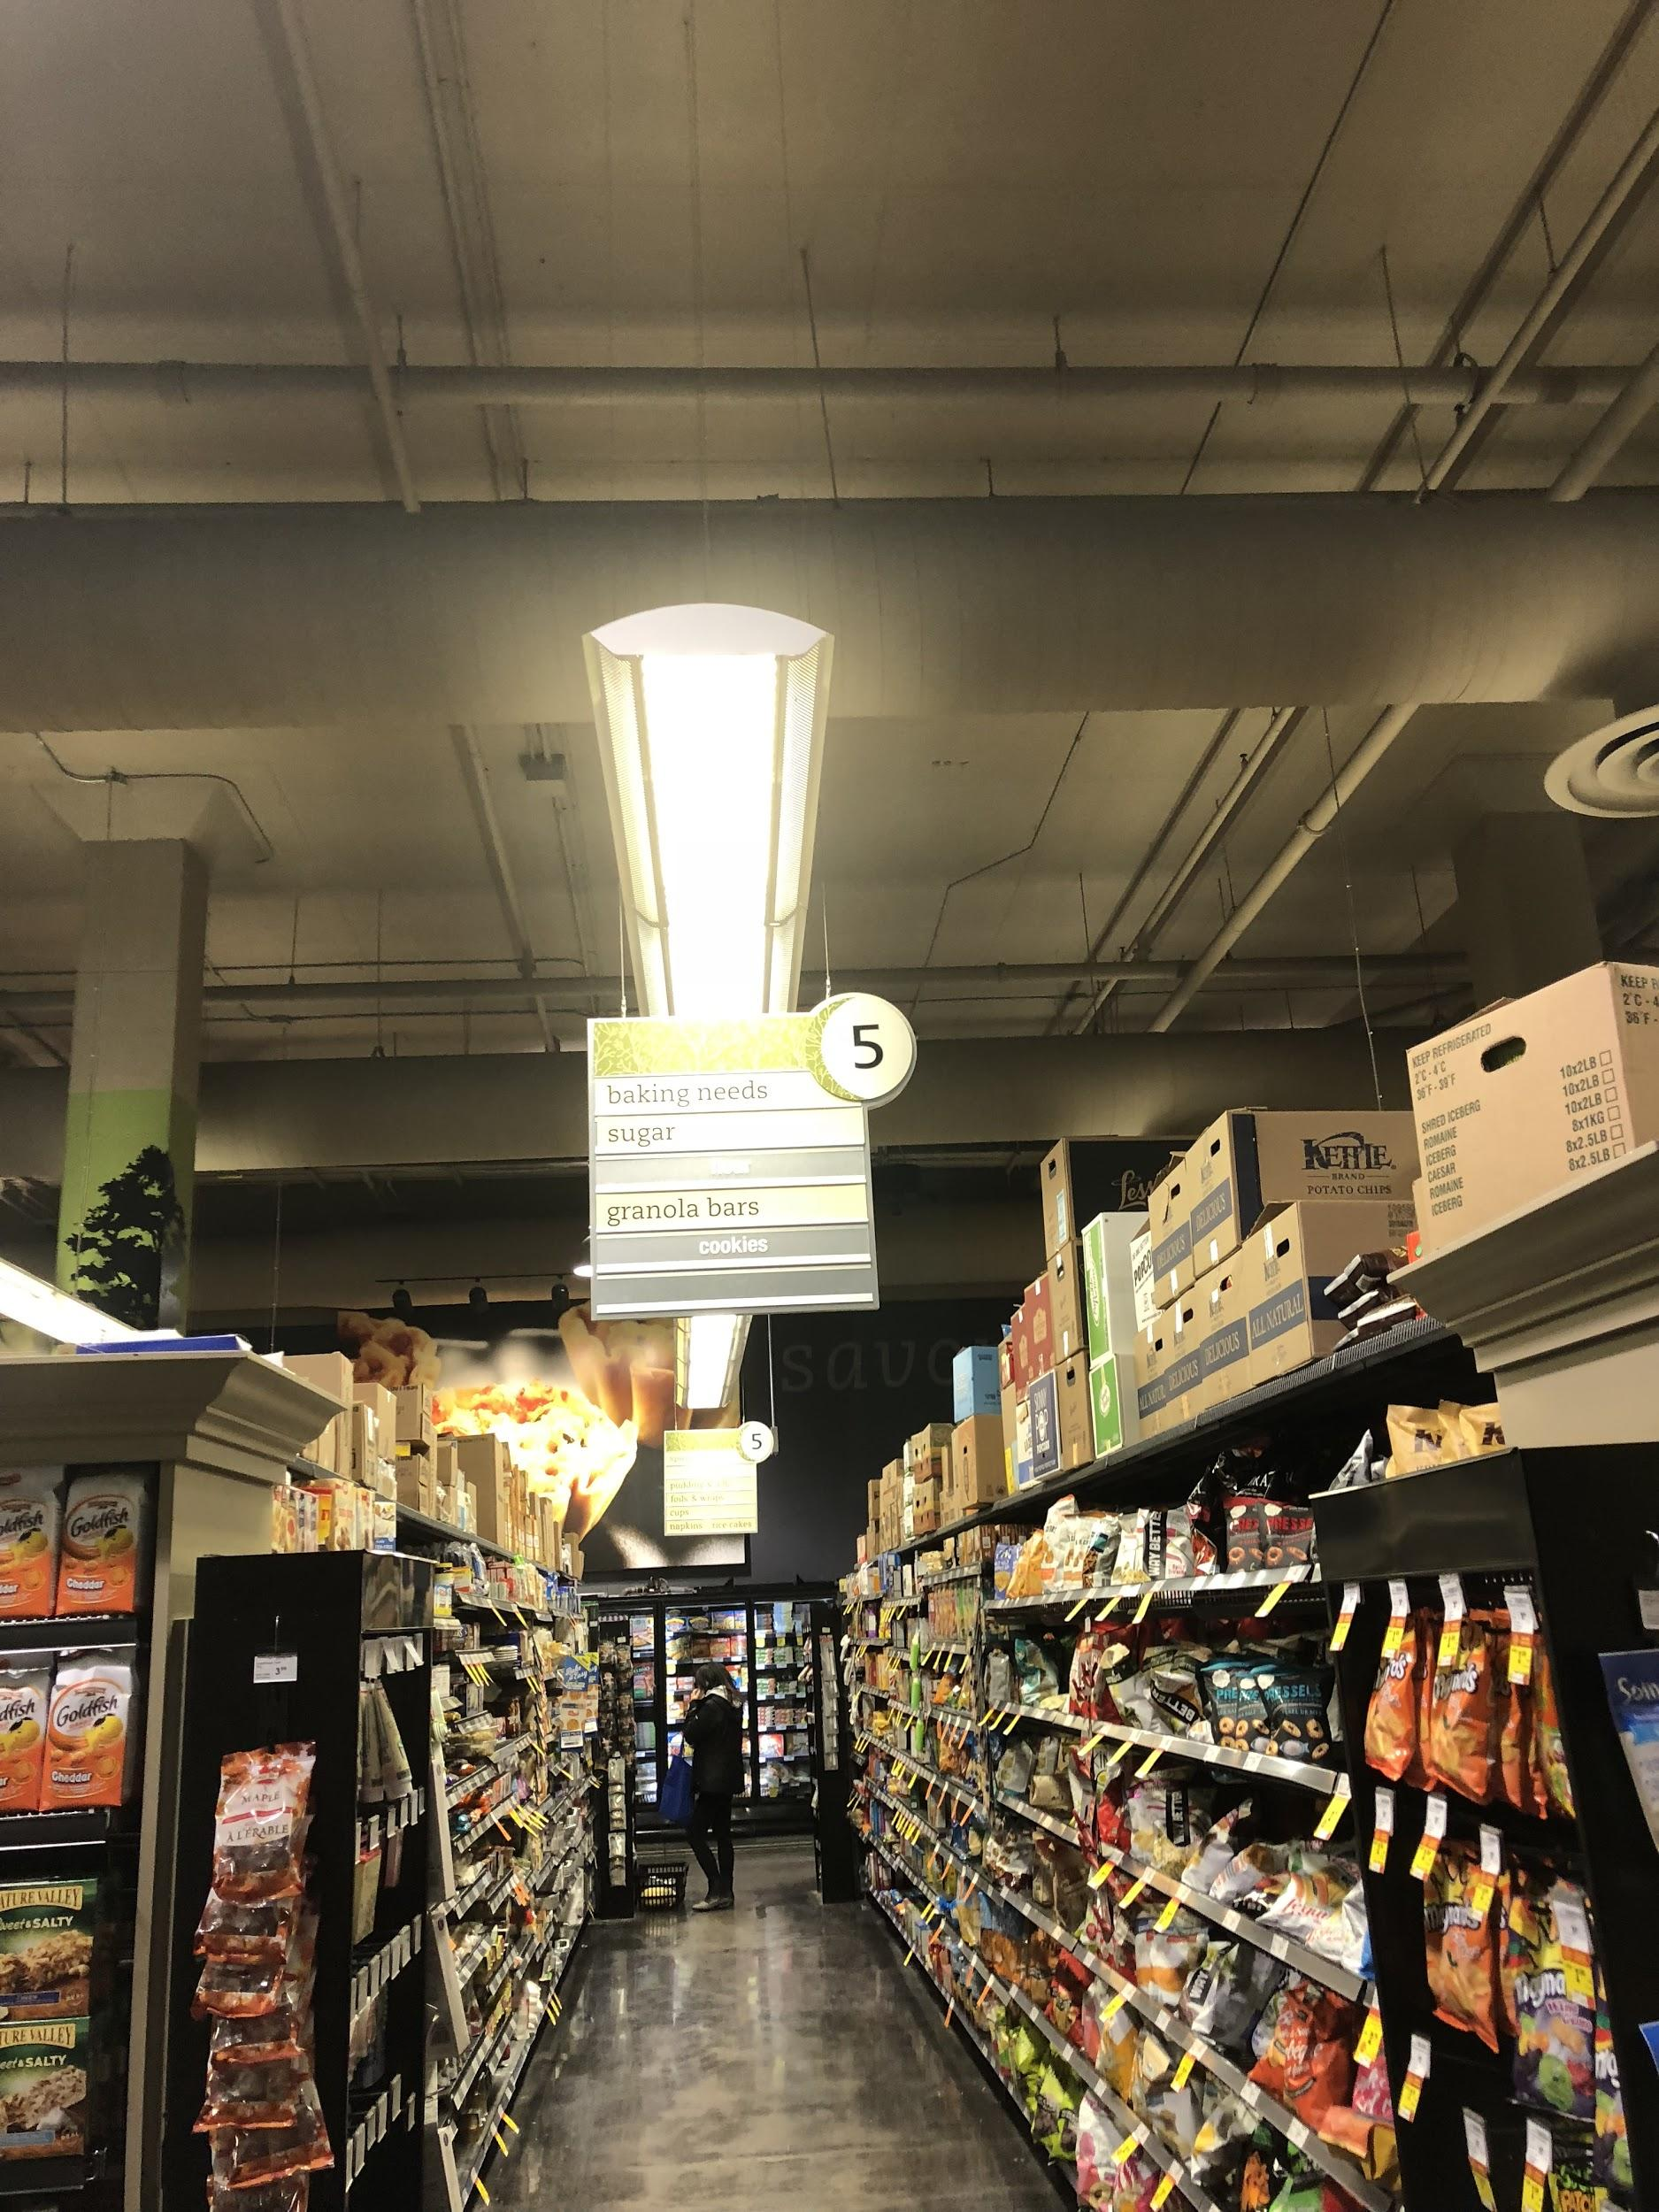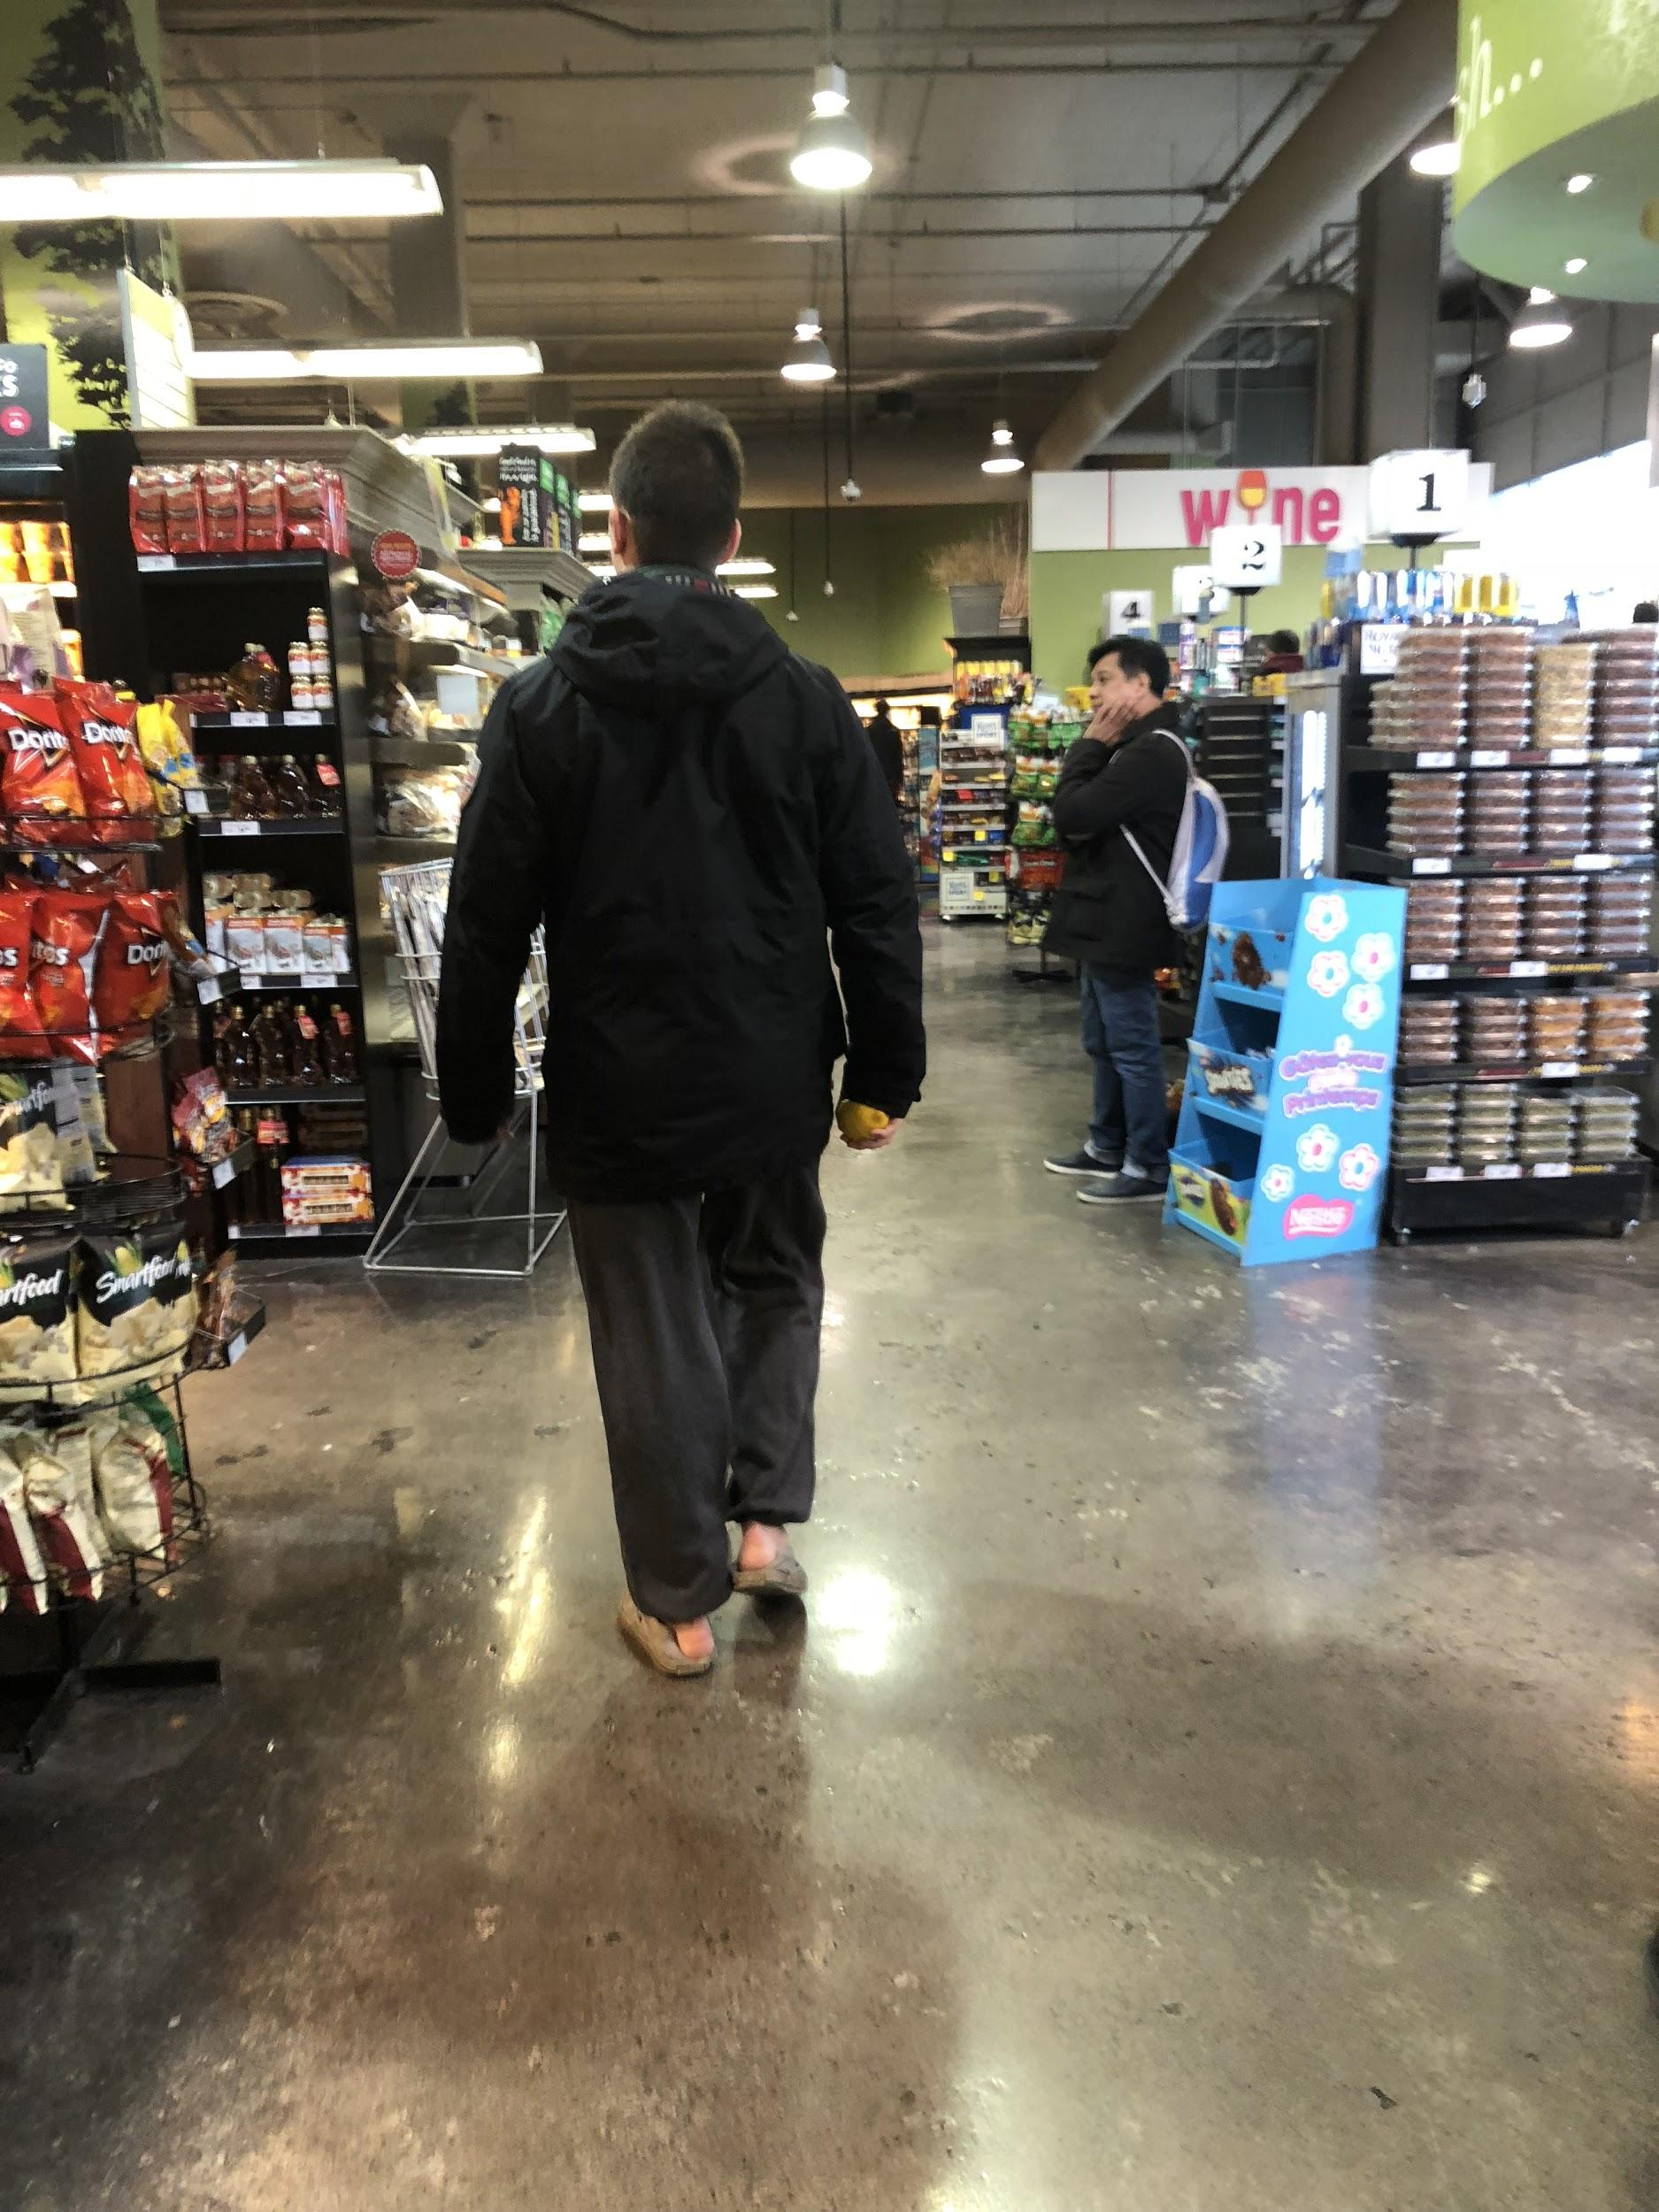
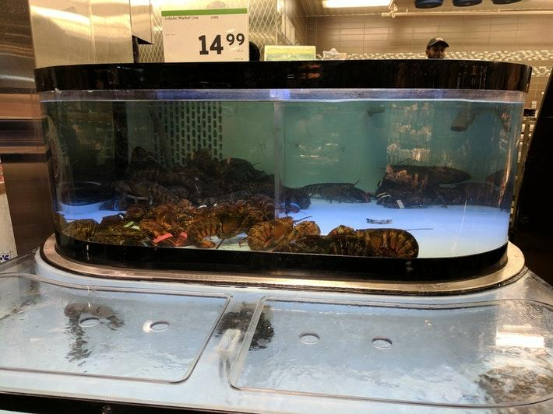
Sobey’s Urban Fresh

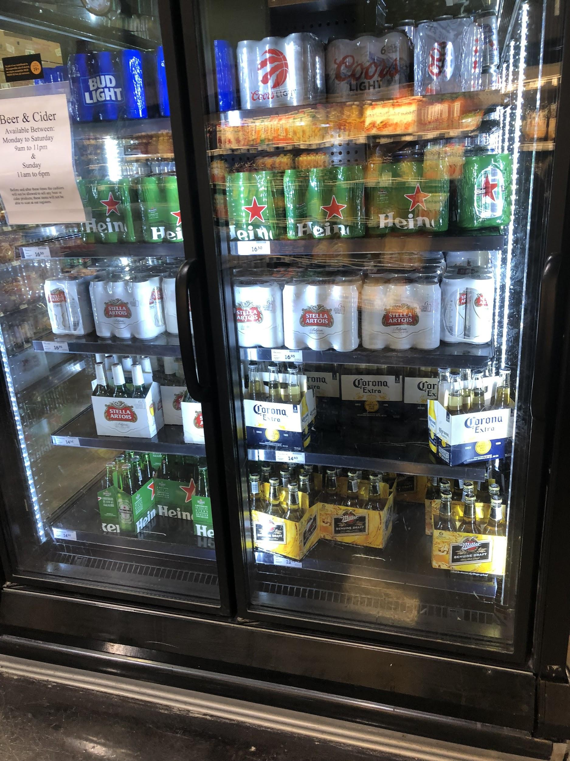
Sobey’s Beer Selection

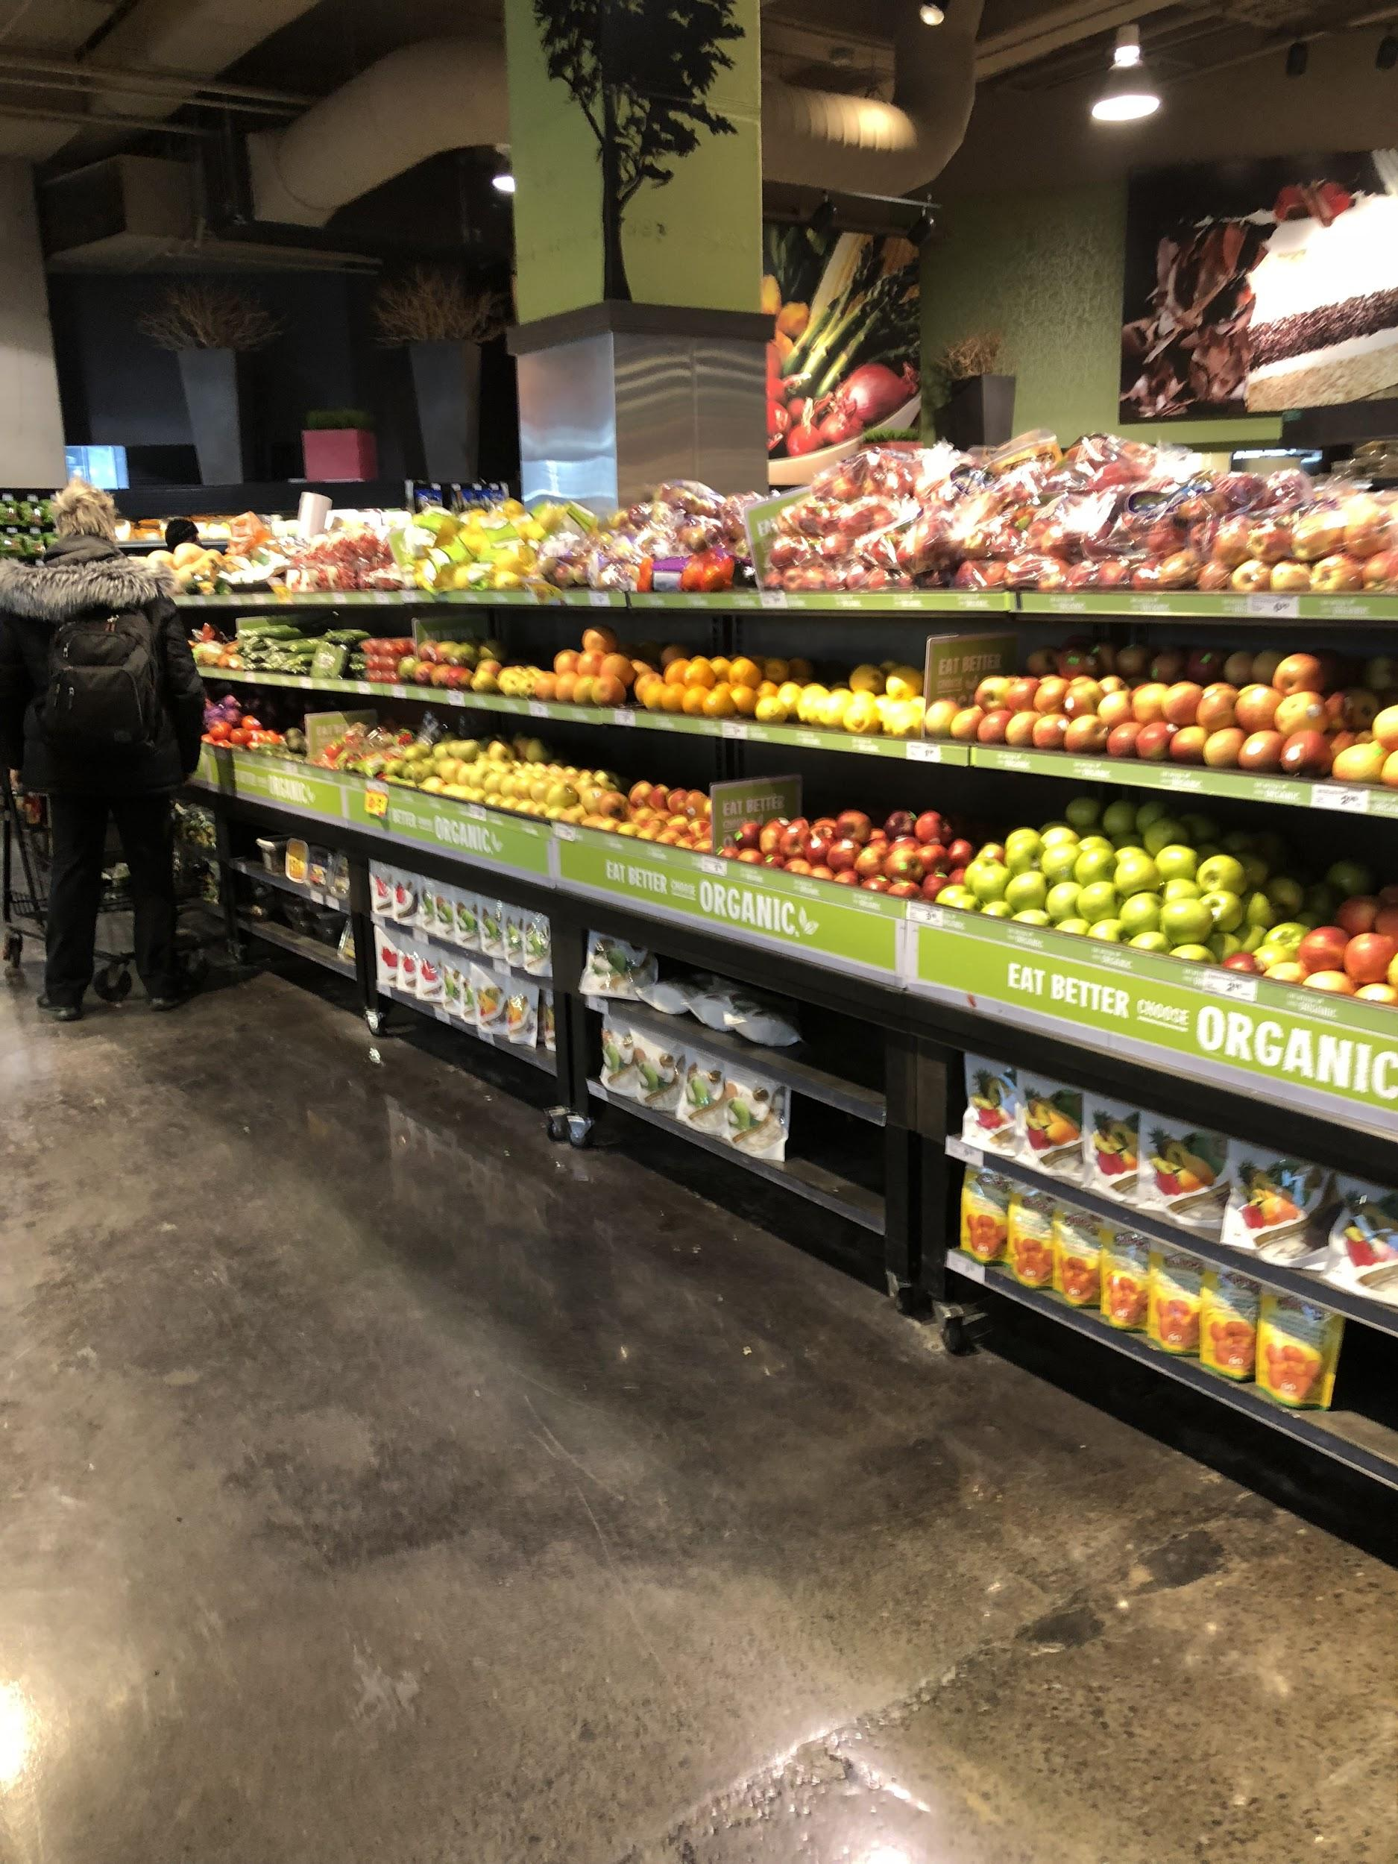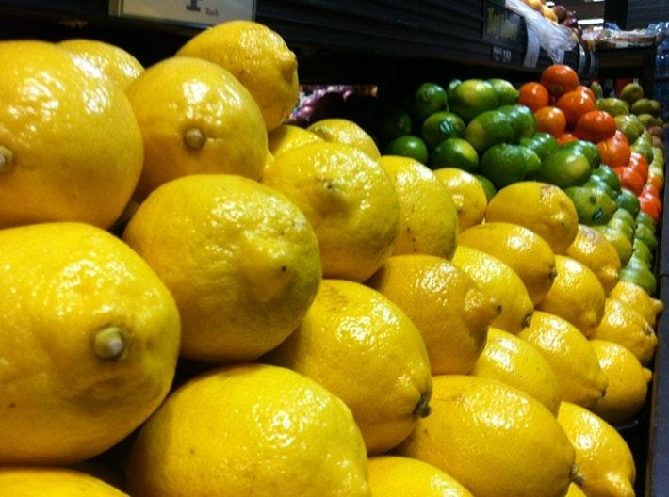
Sobey’s Fresh Fruits and Vegetables
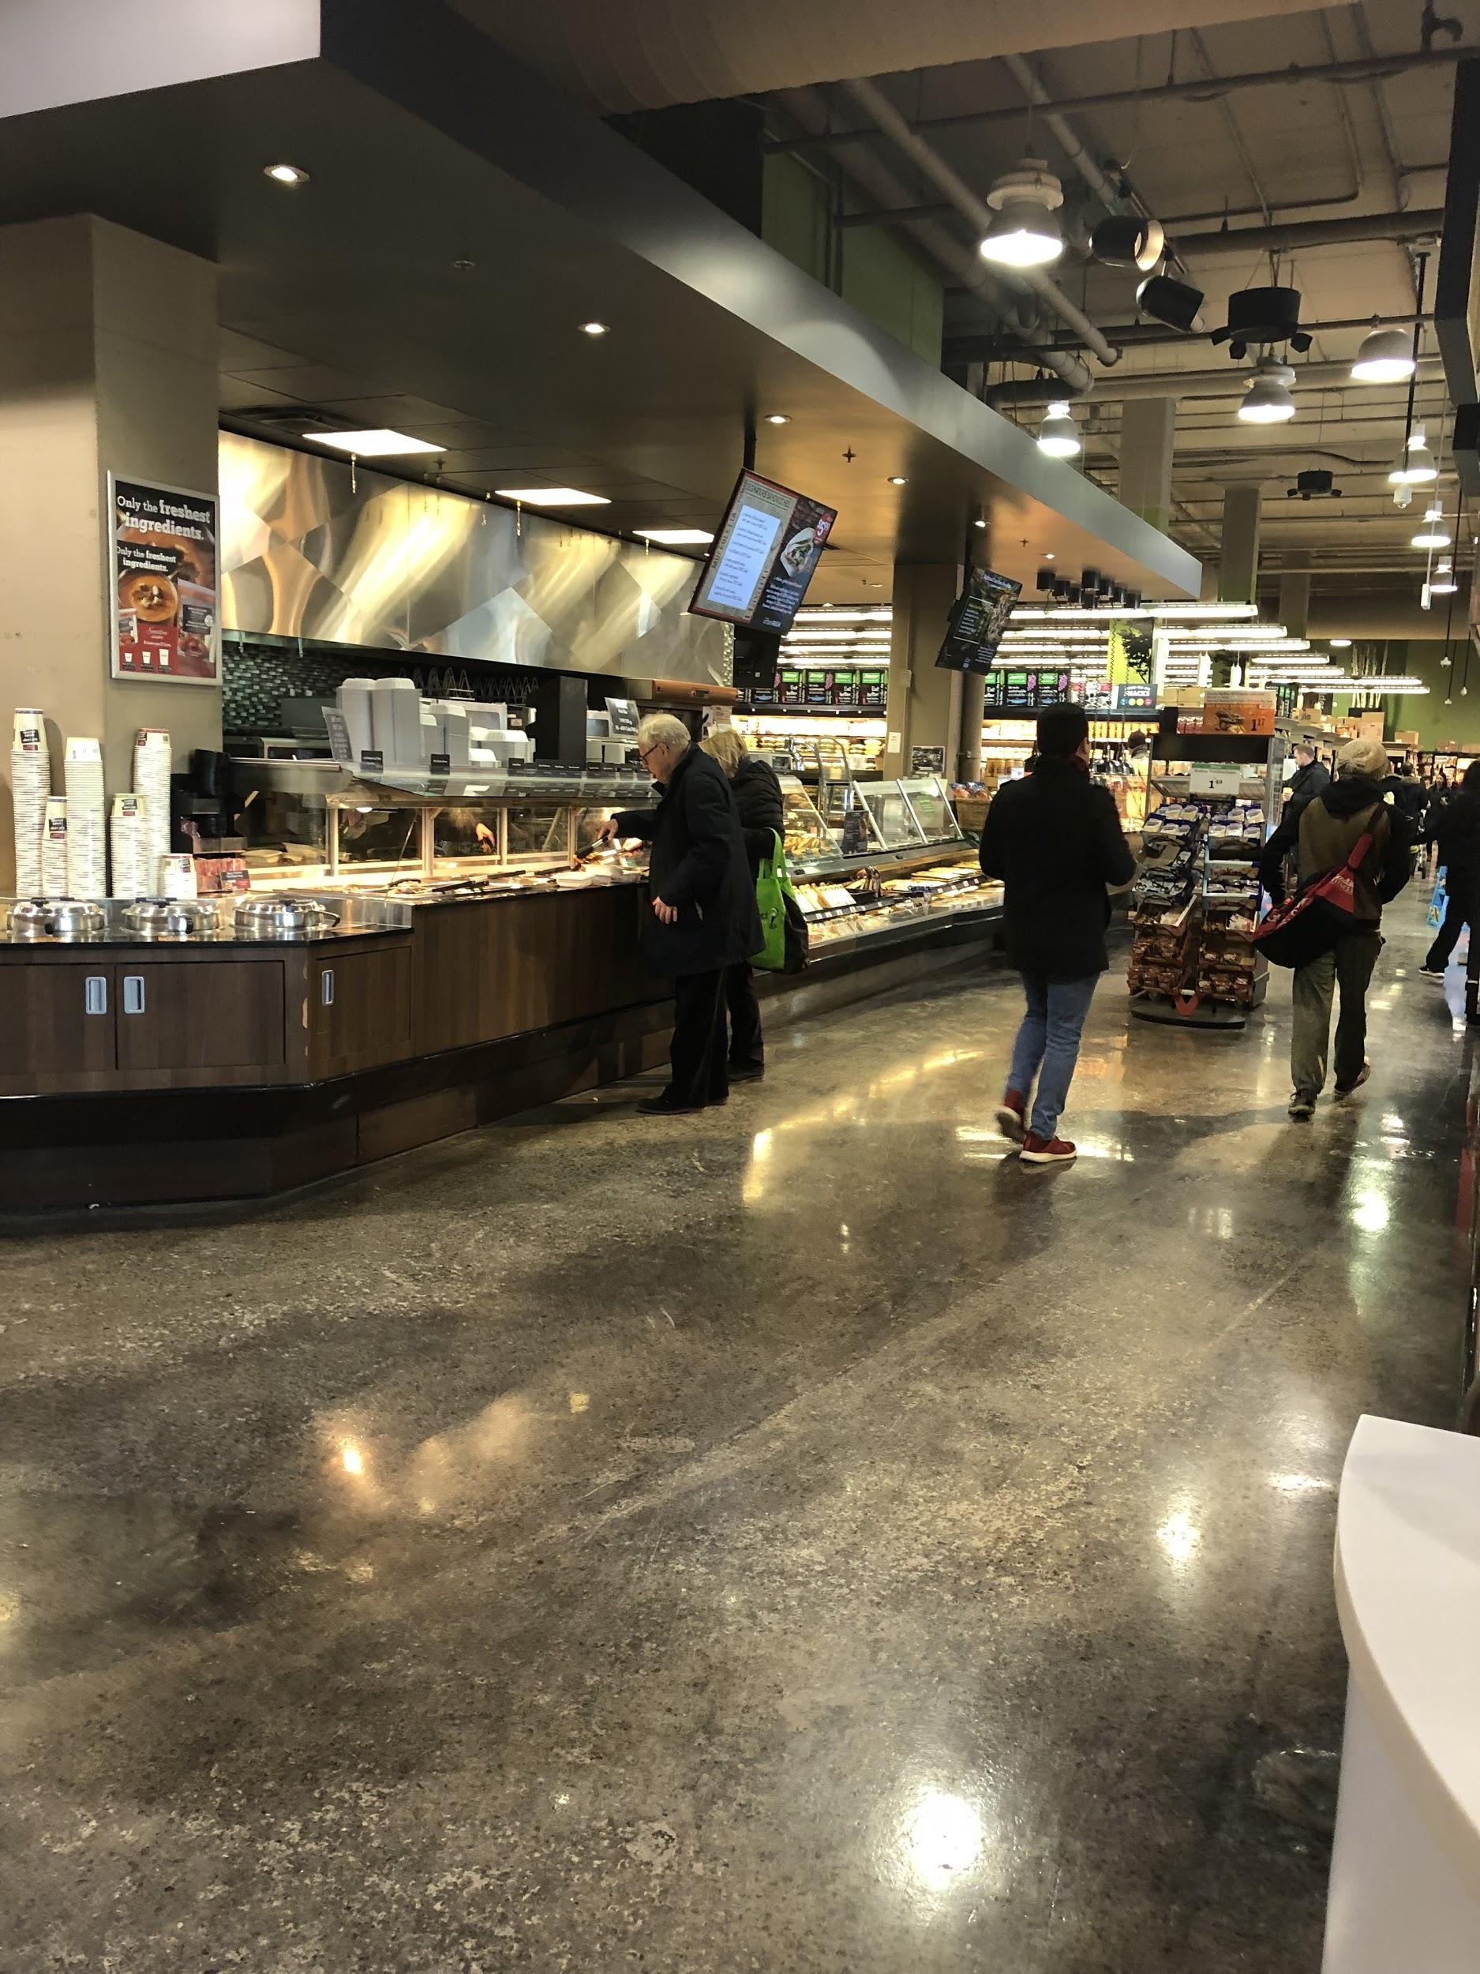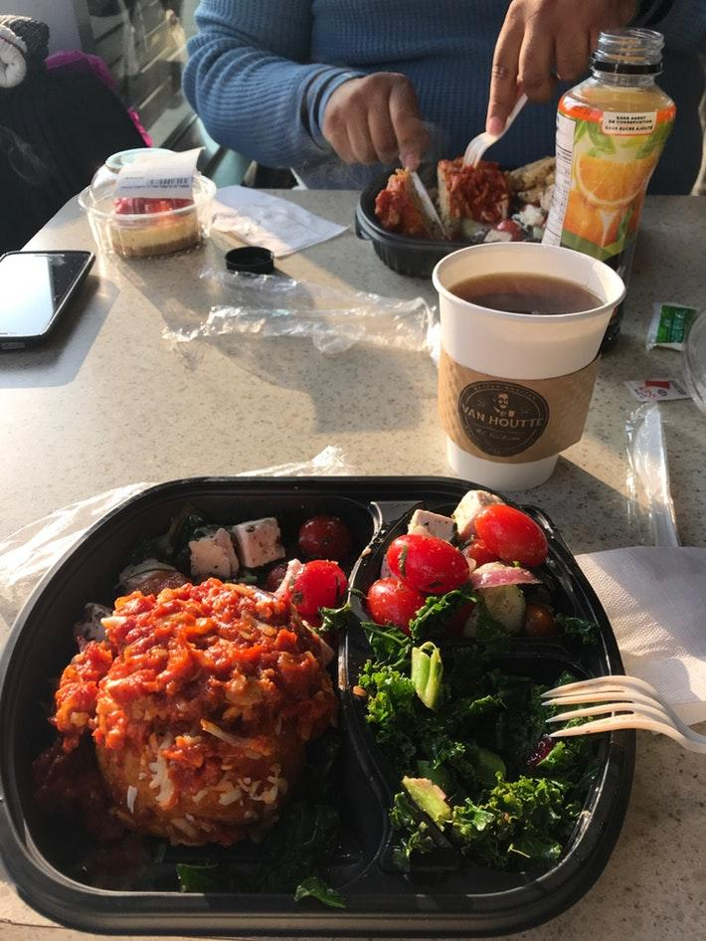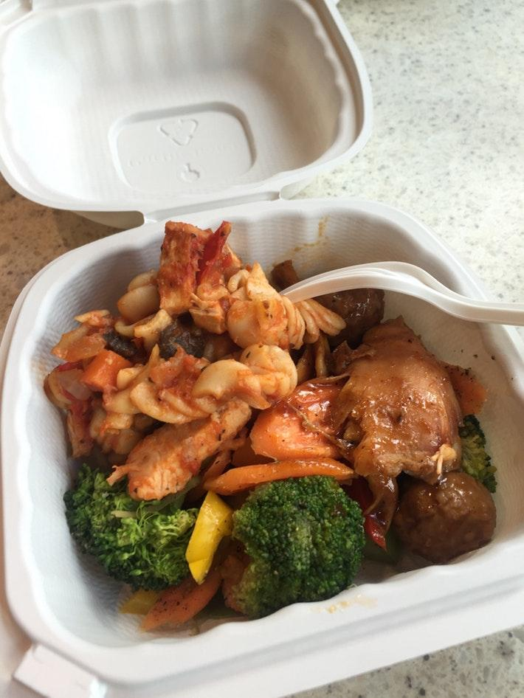
Sobey’s Fresh Foods

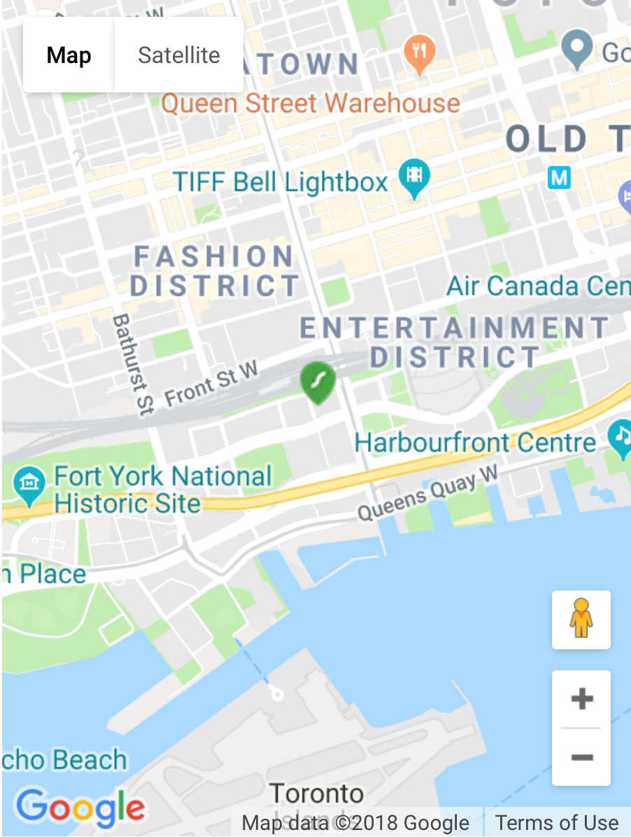

Building connected to Sobeys “30 Telegram Mews”

Interactive Objectives
During this campaign, the agency is working towards 3 major objectives. The campaign will run for an entire month, (October 2018.) The three objectives are:
- Awareness
The objective for the agency is to increase the number of unique visitors to Sobey’s website (https://www.sobeys.com/), by 15% by November 1st, 2018. As of December 2017, there were 280,000 unique visitors to https://www.sobeys.com. (Comscore 2017)
This interactive plan aims to help increase that by 42,000 unique visitors during the 4 weeks of the campaign.
- Consideration
The agency’s objective is to have over 100,000 views during the livestream with an average visit duration of 4 minutes.
- Conversion
The agency aims to increase Sobey’s conversion rate by 10%. More website visitors that complete the desired action - purchasing food items (used in the livestream & other videos) or at Sobey’s stores by the end of the December 2018.

Interactive Strategies
Social Media In-Stream Ads:

The use of social media in-stream ads is highly recommended by the agency. Advertisements will use promoted/sponsored social postings to platforms that include; Facebook, Twitter, and Instagram. As most other social media platforms, any user would be able to retweet, like and share posts with friends/family creating exposure - linking everything back to a similarly alike Sobeys social media page.

The agency found Facebook to be one of the most useful platforms. The Facebook page has almost 7 times the number of followers in than their other platforms. Even though Facebook is still used vividly through younger audiences, the older generations are starting to pick up more on the platform. Sobeys would do well in delivering ways to strongly broaden their social media notice to other platforms used by the younger audience.
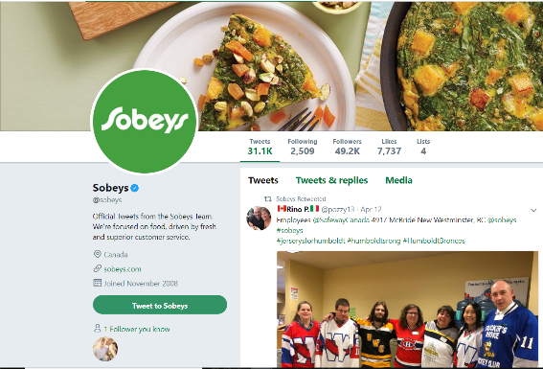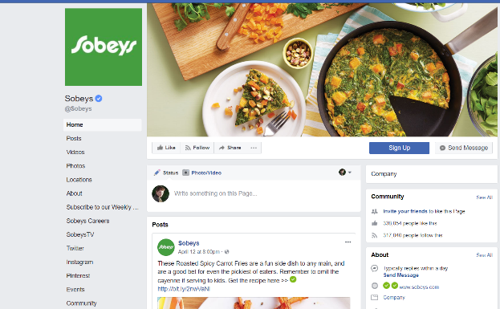
Twitter: 49,200 followers Facebook: 317,040 followers
- 7737 Likes - 338,054 Likes
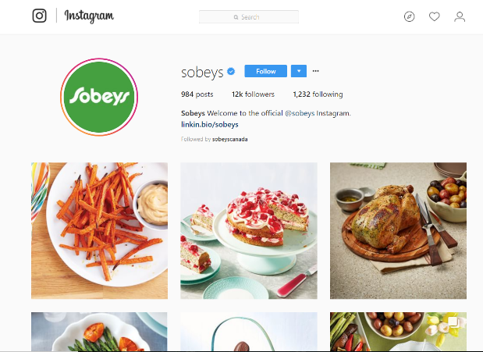
Instagram: 12,000 followers

Sponsored Influencer Posts:

Celebrities or relatively well-known people who have some type of interest in food that has an online impact could be sponsored to talk and cook for Sobeys food events creating awareness to the target demographic. Their goal on the internet would be to have viewers of them to like and share upcoming events and/or to just spread awareness to people about the broad choices of international foods at their local Sobeys. This would produce more social media awareness and followers to support future endeavors.

Such influencers would be used as key points for gain in the lead up to World Food Day. Online cooking shows with head chefs of Sobeys could cook with an influencer to intrigue different ways of having people cook in their own homes with the food from a local Sobeys store.

On World Food Day, Sobeys/ influencers would have livestreams and record videos for their posting platform to spread awareness on the events happening at that time of recording. People at the event could show up on streams and be seen on one of the influencers posting platform and could reminisce on that moment.
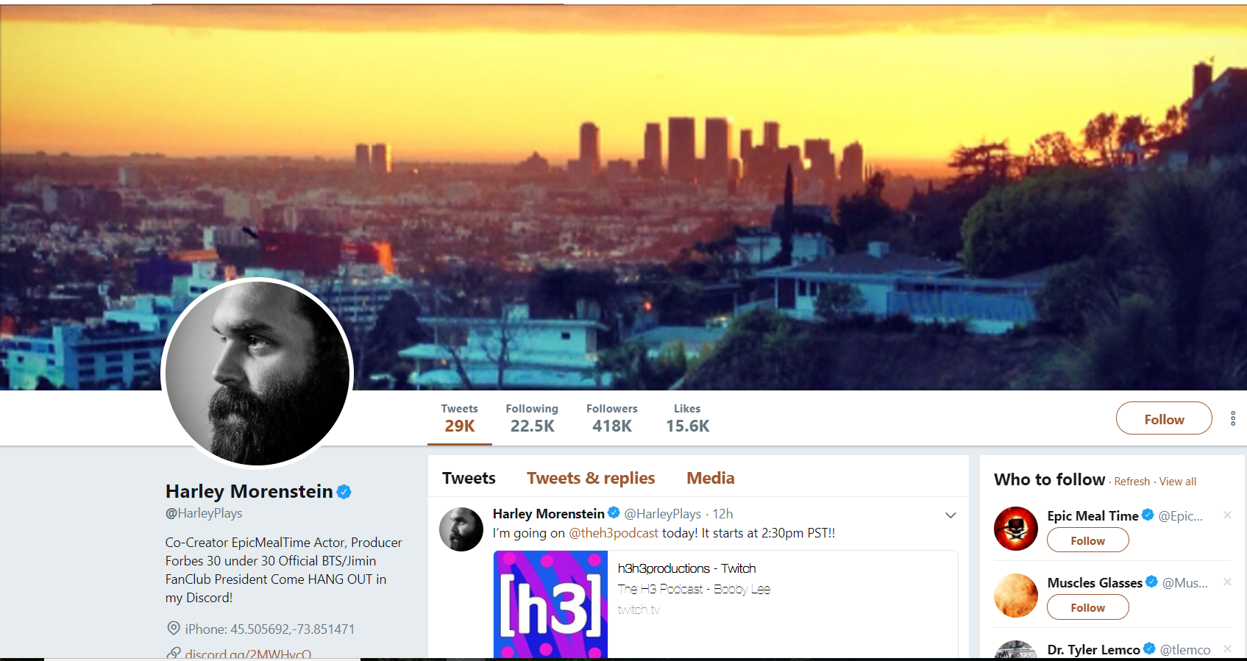
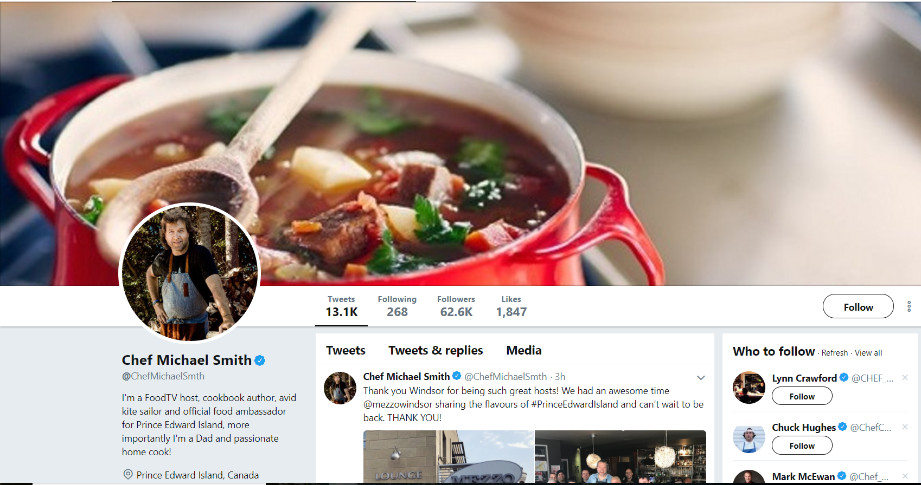
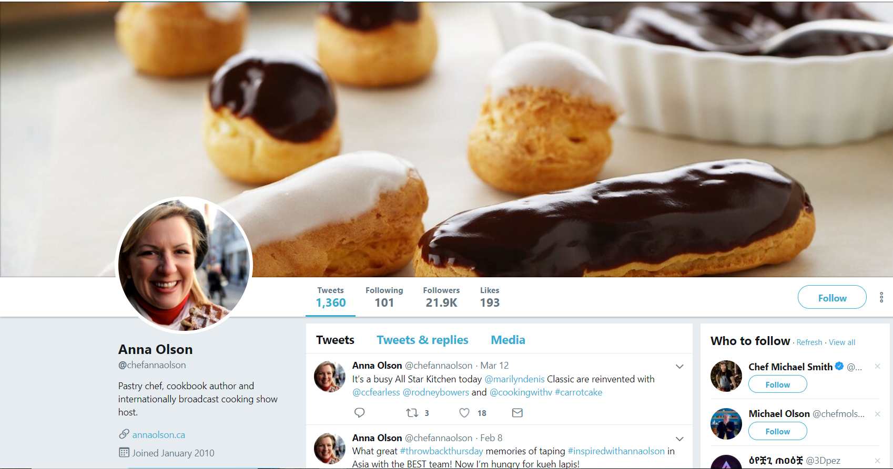
Web Advertisements:

Web Banners linking to Sobey's website homepage and social media homepages would be placed on certain selected websites that all target most of the same demographics as Sobeys overall.

Owned

Revamped Social Platforms:

Newer generations practically live off of social media, though they are starting to tread away from the older sites such as Facebook. Ads will still be placed all over Facebook because of its high viewership on the social platform. However, Twitter and Instagram may need much higher rates for Sobeys to strive in the online world. Images and banners of multicultural campaign designs would bring attention and promotion of this new expanded direction of food choices. It will increase first-time viewers who are looking for either similar or different meal choices.

Snapchat Filters:

A very popular social media platform used mostly by the newer generations out of any other generations is Snapchat. Allowing people who are within a certain radius from a Sobeys to take pictures and use a Sobeys themed filter when either a new food choice is brought to a store or when World Food Day comes around. Having people using filters and send it to their friends will make for more awareness of events or change in menus.

Sobeys Website:

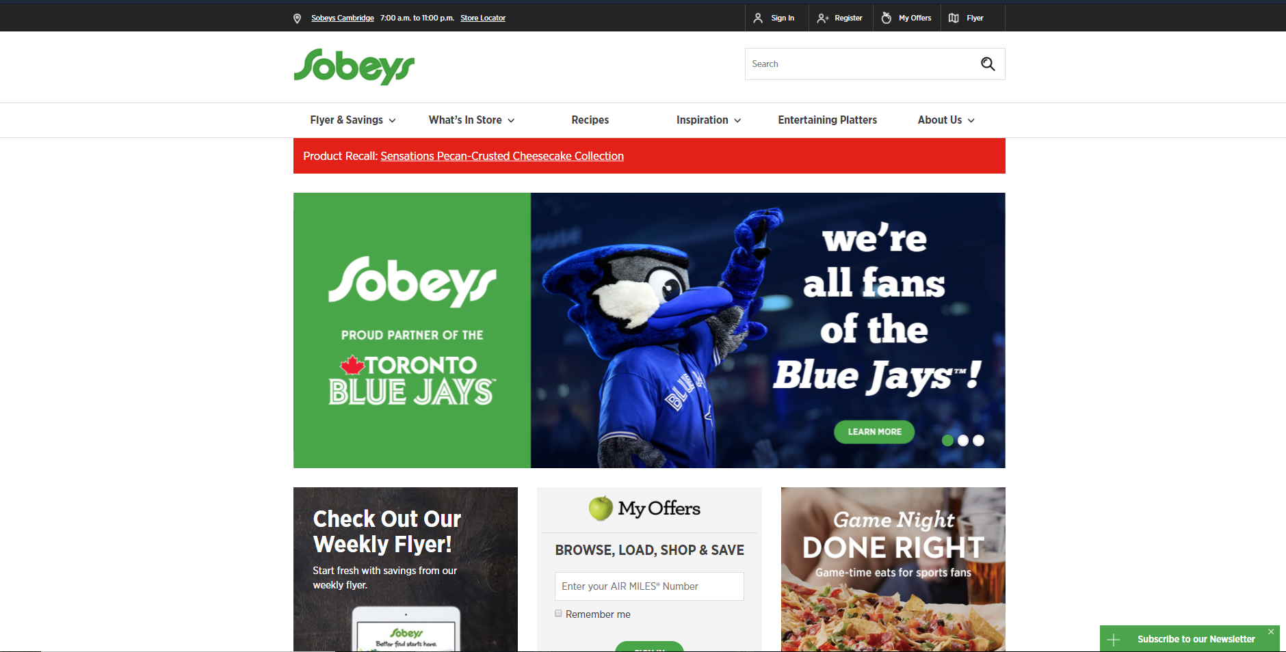
The Sobeys website homepage will bring more awareness with bigger pre-made menu choices and recipes for people to try in their homes through more ad banners. This will create exposure among visitors to the website and let people use the site more for cooking as they decide on the culture they want to choose from and the food choices listed.

Email Newsletters:

Email newsletters would be sent through email blasts featuring the different options of multicultural menu items, recipes and awareness on events revolved around World Food Day or possibly International Food Day with dates on that. The email blasts will also prompt if visitors would like to continue receiving said emails and provide detailed explanations on changes being done revolving the added menu and recipe choices with links to Sobeys social media platforms.

Earned

Sharing Incentives

Social media will be played into effect again, as visitors can share their love for a broader option in foods or World Food Day or International Food Day with the hashtag #InternationalSobeys on all platforms such as Instagram and Twitter.

Local Blog Posts

Bloggers from small to well-known would most likely share opinions and experiences with the recipe directions, taste in different food options and feelings on events revolving around World Food Day and or International Food Day through social media pages and possibly YouTube. Sharing target audiences with such profiles, would bring upon exposure and help gain interest by people towards future choices.

Interactive Execution
The Sobey’s Interactive Plan consists of a unique and innovative campaign idea that no other grocers have done before. This fresh and fun idea will take place during the entire month of October. The main goal of this campaign is to celebrate not only Toronto’s diversity, but Canada’s diversity as a whole. Which is why Sobey’s is to partner up with the United Nations to further strengthen this concept.

The Plan
The main idea and purpose of this entire campaign is to introduce Canadians to fusion food. As a city, Toronto has one of the most diverse populations than any other city in Canada. Because of this, more and more people are drawn to ethnic foods. Whether it be curiosity or not, ethnic food has always piqued the interest of consumers. This is especially more relevant now because people are seeking newer and better flavours which can be seen by observing this statistic for Canada.
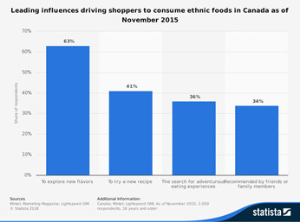
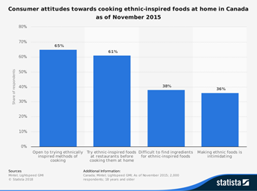
The statistic says that 63% of Canadians as of November 2015 are leaning towards the consumption of ethnic foods because of their wish to “explore new flavours”. That being said, the consumer attitude towards the cooking and preparation of ethnic cuisine has also been leaning towards that direction as well. As of November 2015, 65% of Canadians were “open to trying ethnically inspired methods of cooking”. This is wonderful news because this gives Sobey’s the opportunity to further develop the ethnic market, while innovating it as well.
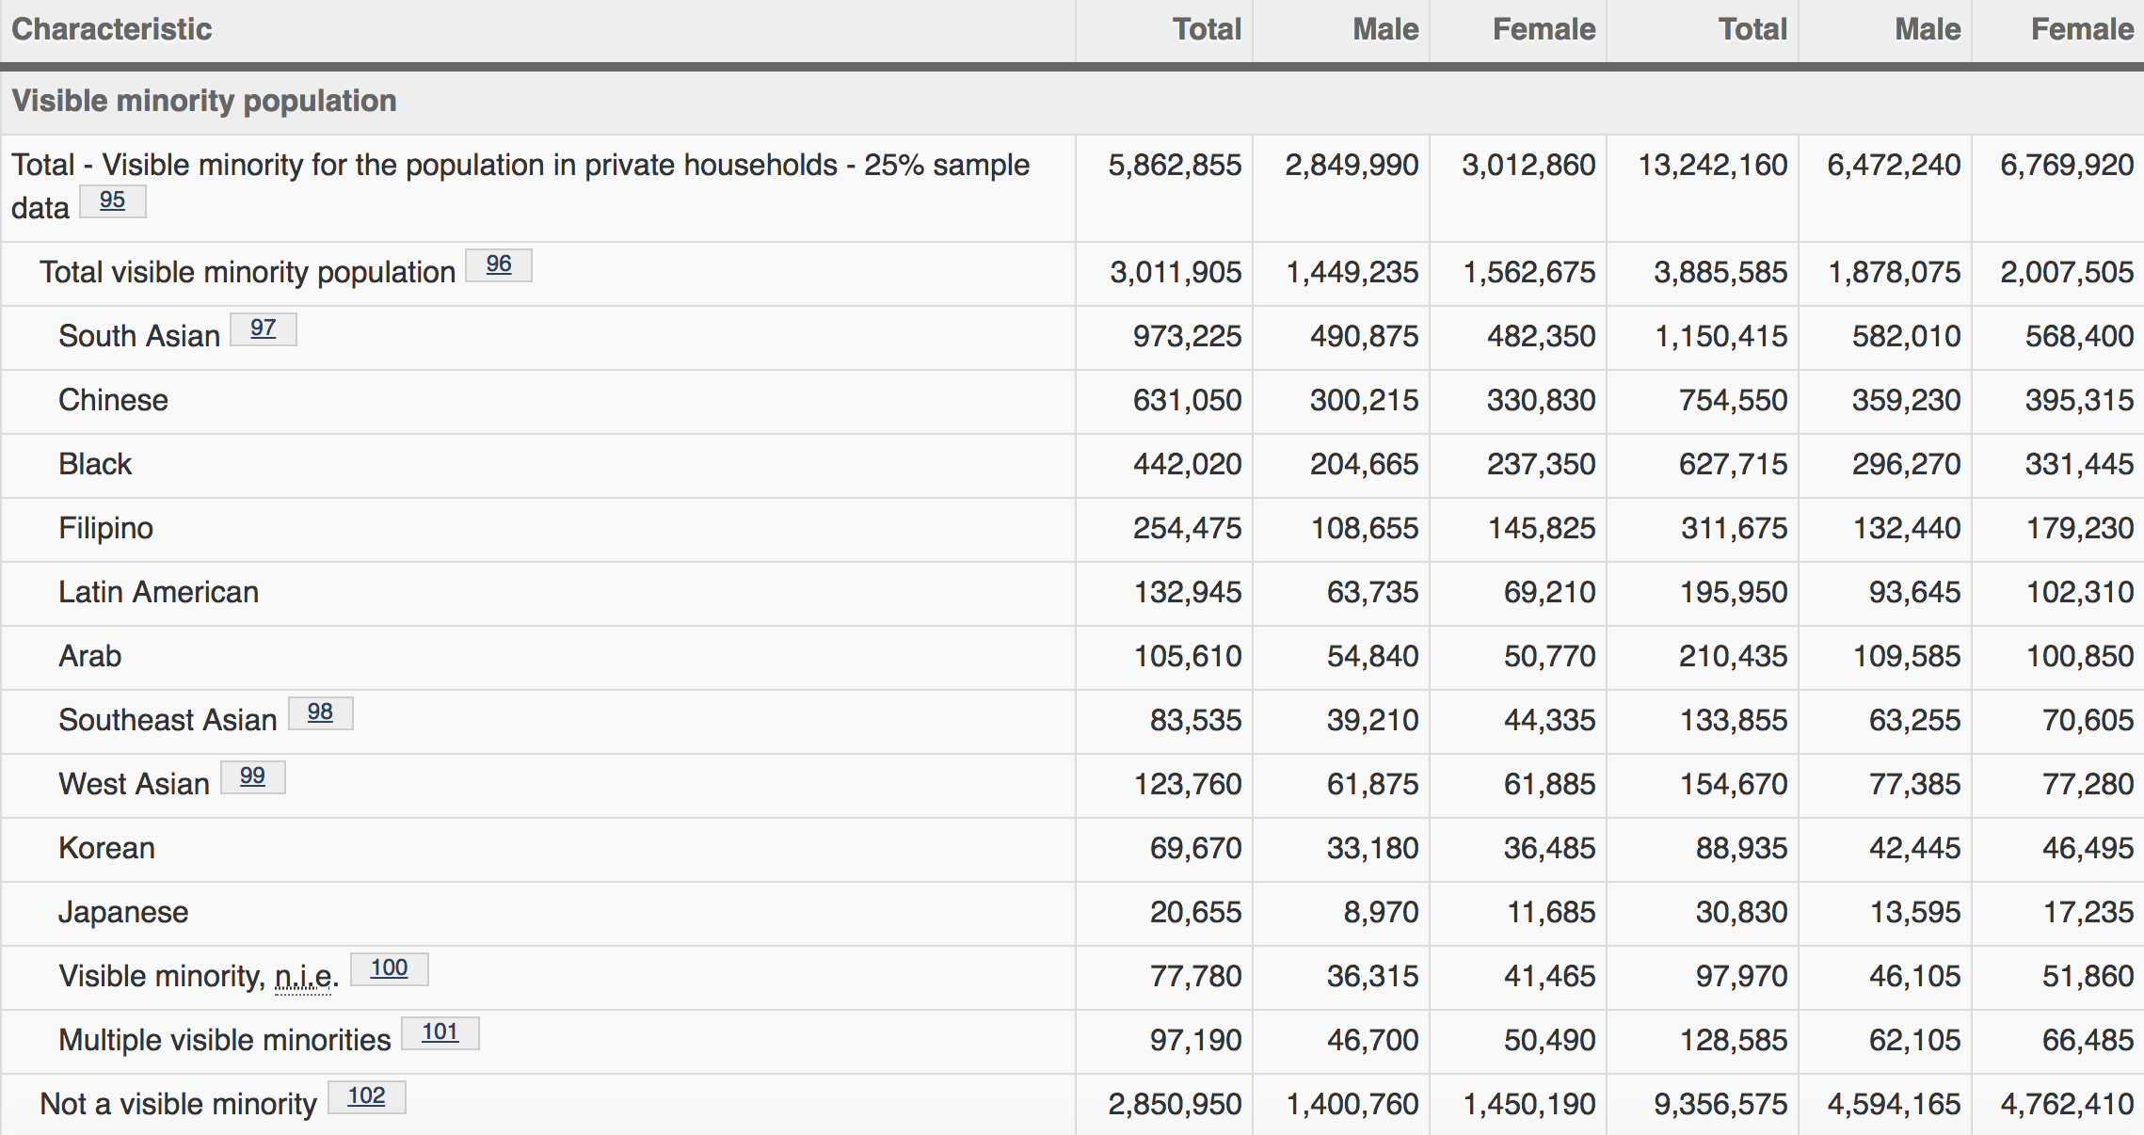
With multiculturalism presented in the 2016 census of Toronto, it is only natural to have a wide array of cuisines out there to try. The city is known for boasting delightful renditions of authentic international cuisines. Toronto has yet to experiment with the fusion of flavours from different ethnicities around the globe. This leaves room for great opportunities to expand on the concept and production of fusion food within the city.

The plan is that Sobey’s will introduce the Torontonian public to the unparalleled charm that fusion food possesses. This will be done by creating and promoting fresh and fun fusion-food recipes and creator driven content that will be posted all throughout the month of October. During the first weeks of the month leading up to October 16th (World Food Day), a raffle-typed contest will be held from the 1st of the month until the 13th. One lucky Canadian winner will be given the chance to star in a Sobey’s livestream event that will take place on World Food Day, alongside a Canadian influencer of their choice. While filming, the winner will be given fusion-food options to choose from. Upon choosing an option, the viewer and influencer are to prepare the chosen recipe in a fun and interactive way. The way to enter the contest is to use a soon-to-be implemented feature called Click-to-Shop.

The Click-to-Shop feature will be displayed on videos and livestreams as a way for viewers to shop items shown in the creator driven content that Sobey’s will be promoting. Items purchased through viewing content can be delivered to the viewer’s house on the same day. Viewers also have the ability to reschedule the delivery of their purchased products to a later date(all rescheduled purchases must be delivered within the month of the campaign). Click-to-Shop will be an implemented ecommerce tool, similar to YouTube’s “I Button”, where items related to the viewed content can be accessed and bought with ease.

If the plan is to be successfully executed, Sobey’s will be able to earn the trust and attention of the millennial generation, while collecting a great amount of earned media by providing the Canadian audience with a fun, interactive, and memorable campaign.

Conclusion
In conclusion, Sobey's interactive marketing plan is an easy, fun, interactive and memorable way to attract customers to shop online at Sobeys. The agency will be targeting people between the ages of 18-34 through the month of October 2018.
The agency’s target is a 15% increase between by November 1st, 2017. The agency adjective is to have at least 100,000 views during our live stream with a duration of 4 minutes. The agency also plans on raising the conservation rate by 10% by the end of December 2018. The agency plans on achieving these goals through three different methods on the internet. These methods are Paid media, Owned content and Earned content..
Paid media
-Promoted sponsorship
-Social media influencers
-Web advertisements
Owned content
-Revamped social platforms
-Snapchat filters
-Sobeys Websites
-Email Newsletter
Earned
-Sharing incentives
-Local Blog Posts
The agency’s plan is to introduce the Torontonian public the charm that fusion food has to offer by promoting our fresh and fun fusion recipes during the month of October which will lead up to World Food Day (October 16th). A raffle type contest will be held and one winner will be given the chance to star in the Sobeys live stream event alongside their favourite influencer.
The only way to enter the contest is through the soon to come option “Click-to-Shop”

Bibliography
Marketing Magazine. (n.d.). Leading influences driving shoppers to consume ethnic foods in Canada as of November 2015. In Statista - The Statistics Portal. Retrieved April 16, 2018, from https://www-statista-com.library.sheridanc.on.ca/statistics/554742/influences-ethnic-food-consumption-canada/.

Mintel. (n.d.). Consumer attitudes towards cooking ethnic-inspired foods at home in Canada as of November 2015. In Statista - The Statistics Portal. Retrieved April 16, 2018, from https://www-statista-com.library.sheridanc.on.ca/statistics/554060/attitude-cooking-ethnic-foods-canada/.

